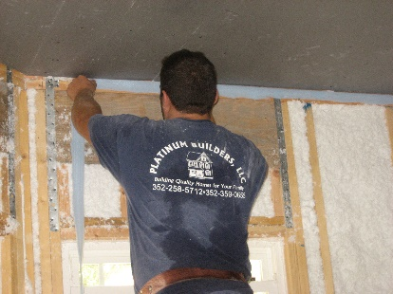 | WHAT?  Sealing the drywall to the top plate is one step in forming a continuous, complete air barrier in the home’s exterior shell.
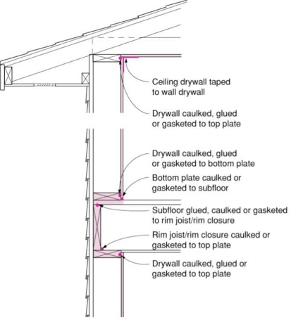 | WHY?  Walls are part of a home’s thermal envelope. If air is allowed to flow through the wall cavity, it can reduce the insulation’s effectiveness and compromise energy performance. Gypsum board drywall is an air barrier material, but it must be taped at the seams and connected at the perimeter to other elements of the continuous air barrier to perform correctly.
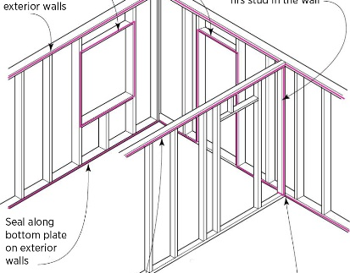 | HOW?  Before installing drywall, apply a continuous bead of caulk or glue or staple a strip of compressible foam gasket material along the top plate and bottom plates of exterior walls. Do the same thing for rough openings around doors and windows, and for interior walls that intersect insulated ceilings. Install drywall over the caulk, glue, or gasket material. Mud and tape drywall as you usually would. Sealing can be accomplished after drywall is installed by sealing the seam from the attic side with caulk, foam, or drywall adhesive.
DRYWALL INSTALLATION: AIR SEALING DRYWALL TO TOP PLATE

