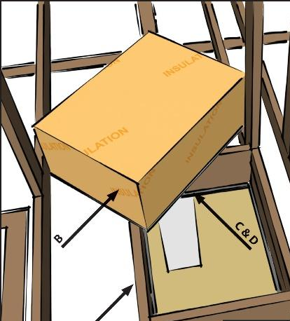 | WHAT?  Openings used for access to the attic such as access panels, doors into kneewalls, or dropdown stairs should be air sealed. This is accomplished by adding weatherstripping to either the frame or panel of the attic access panel or door. Latch bolts or mechanical fasteners should be installed that will pull the access door tight to the weatherstripping, ensuring an airtight seal.
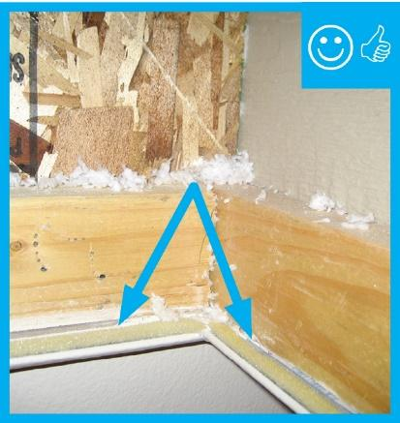 | WHY?  Good air sealing and a continuous air barrier between the attic and the home’s conditioned space save energy and reduce fuel bills; these practices also prevent moisture problems in the attic. Sealing holes in the attic ceiling reduces the house’s “suction” (or stack effect) so fewer contaminants (such as radon and other soil gases) are drawn up into the house from the ground.
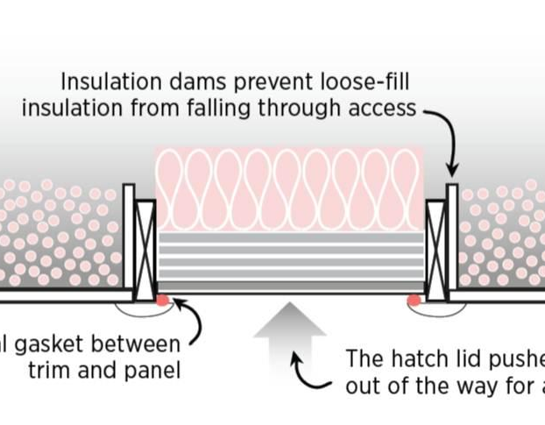 | HOW?  Install a gasket around attic access openings to air seal between the opening and the panel covering. Insulate the cover with rigid foam that is glued in place or batt insulation that is mechanically fastened with wires and screws. Install a durable, insulated cover for drop down stairs that provide attic access and install an air-sealing gasket around the rim of the panel. Around the staircase or panel, install blocking to serve as a dam to keep insulation from falling out.

