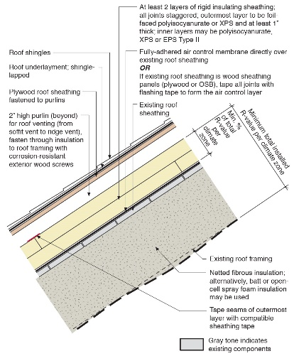 | WHAT?  An air control layer is an essential part of a high-performance roof enclosure that includes one or more layers of exterior rigid insulation. The air control layer is installed directly on top of the roof sheathing before the rigid insulation is installed.
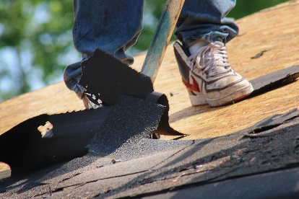 | WHY?  A retrofit that involves re-roofing provides a great opportunity to install rigid foam insulation above the roof deck and create a high-performance roof enclosure.  An air control membrane is needed below the insulating sheathing to prevent moisture-laden air from migrating through the joints in the insulating sheathing. With the right materials and detailing, the air control membrane can also provide temporary water protection and permanent back-up water protection.
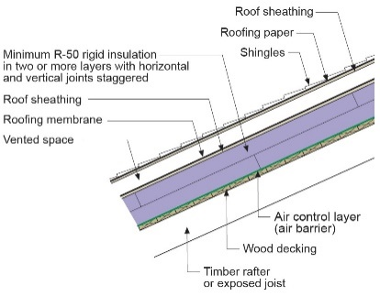 | HOW?  There are three options for the air control layer:  Good: The original non-adhered roof underlayment is made air tight by taping the seams and applying sealant or tape.  Better: The original sheathing product has a self-adhered air and water control membrane that is an integral part of the sheathing product.  Best: A fully adhered, self-sealing ice and water control membrane is installed over the original sheathing with any seams overlapped shingle style.
ROOFING: AIR CONTROL LAYERS AND RIGID INSULATION

