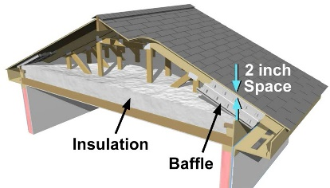 | WHAT?  In vented attics, the thermal boundary is at the level of the ceiling. In these homes, the ceiling—which usually consists of taped, mudded drywall—provides the air barrier and the insulation is placed on top of it. The attic space above is unconditioned, or uninsulated.
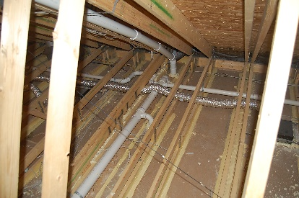 | WHY?  Attics are a common source of heat energy loss in homes. For the best performance, the home’s thermal layer should be fully aligned—in full continuous contact—with the air barrier. In homes with vented attics, the ceiling usually serves as the air barrier and the insulation is installed directly on top of it.
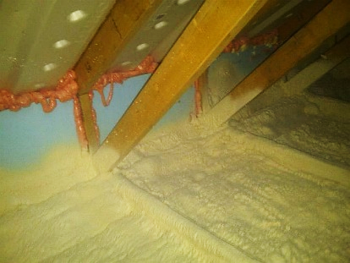 | HOW?  While the air barrier usually consists of drywall that is taped and sealed at seams, other durable, solid surfaces such as plywood, OSB, or housewrap that is sealed at the seams, are also acceptable. Kraft paper, paper products, or other materials that tear easily should not be used. If spray foam insulation is used, the spray foam can serve as the air barrier if it is at least 5.5 inches thick if open-cell or at least 1.5 inches thick if closed-cell. The air barrier should be continuous and in full contact with the insulation, with all holes (for wiring, electrical boxes, light fixtures, flue and chimney pipes, duct chases, heating registers, soffits, etc.) thoroughly air-sealed before insulation is installed.
INSULATION PROCESS/REQUIREMENTS: CEILINGS: AIR BARRIER IN VENTED ATTICS

