**Building Science Education Solution Center – Introduction to Heat Pump Water Heaters**

Proficiency Level 2: Understand

**Learning Objective 2.1:**

* Describe how a Heat Pump Water Heater (HPWH) heats water

**Lecture Notes 2.1:**

# References:

DOE. *Heat Pump Water Heaters*. n.d. 2022. <https://www.energy.gov/energysaver/heat-pump-water-heaters#:~:text=Heat%20pump%20water%20heaters%20use%20electricity%20to%20move,heat%20pumps%20work%20like%20a%20refrigerator%20in%20reverse.>.

Hot Water Solutions. *HotWaterSolutionsNW.org: Heat Pump Water Heaters Cut Electric Bills*. n.d. 2022. <https://hotwatersolutionsnw.org/>.

**How does a HPWH heat water?**  
A HPWH uses the heat and humidity from the surrounding air to heat water inside its insulated tank. An example of the components and process that make up a HPWH can be seen in (Figure 1). The process begins when a fan pulls in air and transfers the heat in the air to an evaporator coil filled with refrigerant. The refrigerant changes state from a liquid to vapor and is then transported to a compressor to further increase the pressure and temperature of the refrigerant gas. The compressor pumps the refrigerant vapor through a heat exchanger coil that is lined around the insulated water tank. The heat from the refrigerant is transferred to the water. In the process, the refrigerant returns to a liquid state as it cools and runs through an expansion valve. The refrigerant returns to where it first began, and the process repeats. The heated water in the tank is then distributed to the home’s water fixtures and appliances through a network of pipes. In addition, cooled dehumidified air is exhausted back into the surrounding space after it runs past the evaporator. As a backup measure, 240-volt HPWH models also contain electric resistance elements, such as those found in conventional water heaters, for times in which the HPWH is unable to produce enough hot water to meet demand. This can happen when the surrounding air isn’t warm enough to transfer heat, such as when the air temperature is below the compressor cutoff temperature of approximately 40 °F (4.4 °C).

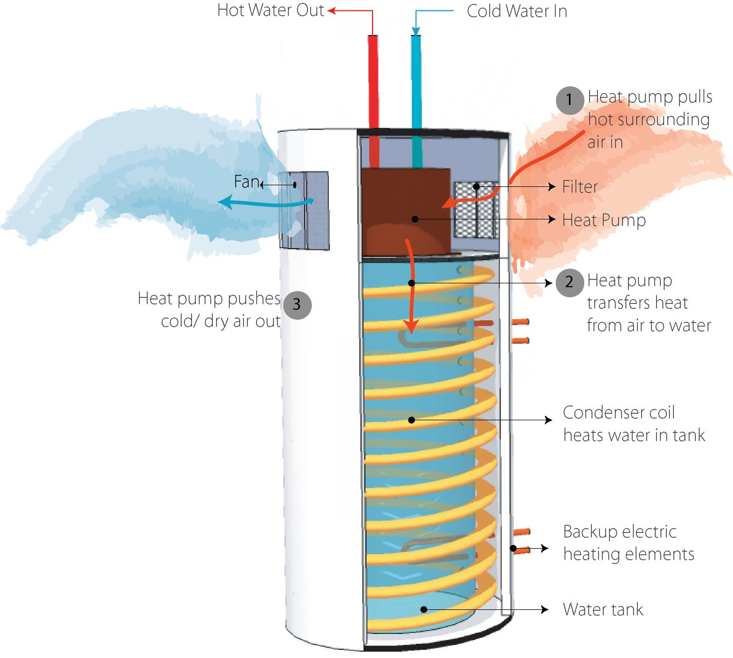

Figure 1 Components of a Heat Pump Water Heater. Image retrieved from: [Field Performance of Heat Pump Water Heaters in the Northeast (energy.gov)](https://www1.eere.energy.gov/buildings/publications/pdfs/building_america/64904.pdf)

Problem Set 2.1

1. What is the source of heat used by the HPWH to heat up the water inside the insulated tank?
2. What substance goes from liquid to gas, and back to liquid in order to transfer heat to the water in the storage tank?

**Learning Objective 2.2:**

* Recognize what factors to consider when choosing a HPWH

**Lecture Notes 2.2:**

# References:

DOE. *Heat Pump Water Heaters*. n.d. 2022. <https://www.energy.gov/energysaver/heat-pump-water-heaters#:~:text=Heat%20pump%20water%20heaters%20use%20electricity%20to%20move,heat%20pumps%20work%20like%20a%20refrigerator%20in%20reverse.>.

—. *New Infographic and Projects to Keep Your Energy Bills Out of Hot Water*. n.d. 2022. <https://www.energy.gov/energysaver/articles/new-infographic-and-projects-keep-your-energy-bills-out-hot-water>.

—. *Sizing a New Water Heater*. n.d. 2022. <https://www.energy.gov/energysaver/sizing-new-water-heater>.

ENERGY STAR. *Considerations – Heat Pump Water Heaters (HPWHs)*. n.d. 2022. <https://www.energystar.gov/products/water_heaters/high_efficiency_electric_storage_water_heaters/considerations#ftn4>.

**Determine Ideal Size for HPWH**  
Sizing a HPWH to a household’s hot water demand is important to maximizing energy efficiency benefits. Since HPWHs can take longer to recover compared to conventional electric resistance water heaters, storage tank size ensures adequate hot water delivery. For 240-volt HPWHs, increasing tank size can decrease operation of inefficient electric-resistance back-up, and thus maximize return on investment. Since typical 120-volt HPWHs have a smaller electric resistance element or no back-up heat source, choosing the appropriate tank size or identifying a model with an integrated mixing valve can help prevent hot water run outs. If the storage tank is too small, the HPWH runs the risk of being unable to provide the needed amount of hot water and frustrating occupants. If the homeowner is unsure on what size to choose, it is generally better to oversize than to undersize a HPWH. While an oversized HPWH will have increased stand-by losses, it would still be more energy efficient than an electric water heater.

When determining an appropriate size of a HPWH for a household, a couple factors should be considered. The first is the number of occupants, and their hot water usage habits. Careful consideration should be given to the “First Hour Rating” (FHR) value found on the yellow energy label. The higher the FHR, the higher the quantity of hot water the HPWH can deliver in a single hour. If the homeowner may sell the house in the next ten years, it’s better to use number of bedrooms to size the HPWH rather than number of occupants. More details on how to better determine the ideal size of a HPWH can be found in the **HPWH - Decision Guidance** module.

**Initial Cost of HPWH**  
The installation cost of an efficient HPWH is generally two to three times larger than that of a conventional water heater. Because of that, it is important to take into consideration the yearly energy consumption (See the Level 3 module) to determine operational costs. With this information, a potential buyer can get a rough estimate as to how many years of reduced energy bill costs is needed to offset the initial purchase cost difference between a HPWH and a conventional water heater.

**Limitations of HPWH Location**   
Since typical HPWHs require a supply of roughly 40 °F (4.4 °C) or warmer air to operate most efficiently, installation locations may be limited and should be addressed on a case-by-case basis. HPWHs should either be installed in a room with at least 700 cubic feet (19.8 cubic meters) of air space around the water heater or the ability to make modest alterations (e.g., louvered door, intake/exhaust ducting) to provide airflow when less than 700 cubic feet (28.3 cubic meters) of air is available. Depending on the model, some HPWHs can also work effectively in smaller spaces such as 450 cubic feet (12.7 cubic meters).

**Other Considerations**  
Ideally, HPWHs are installed in locations that remain above 40°F (4.4°C) year-round. Below this temperature, the compressor may turn off. However, certain installation locations (e.g., garages) may fall below 40°F (4.4 °C). In this case, a HPWH with back-up electric resistance is preferable to prevent hot water run out when it’s cold. If a HPWH without back-up is the only viable option, then a model with an integrated mixing valve and/or a larger tank size may limit a hot water run out if the installation location falls below 40°F (4.4 °C) only occasionally (e.g., winter nights). If the location’s temperature falls below 40°F (4.4 °C) regularly during certain times of year, then a HPWH without back-up may have issues providing adequate hot water delivery. In this scenario, it may make sense to duct the HPWH both in and out of conditioned space so it can meet household demand or consider moving the HPWH.

Because of the addition of the heat pump on top of the tank, HPWHs tend to be taller than their conventional counterparts, so the space should be tall enough to accommodate for the additional height (approximately 12-18 inches (30.5 – 45.5 centimeters) taller). The height and space clearance around the HPWH should also be sufficient such that there can proper airflow for both the intake and output vents and access to the filter for cleaning/rinsing.

In addition to the items above, other factors should be considered. HPWHs create noise (approximately 50 dB) and vibration, so they should be installed in locations where noise and vibration are not an issue (e.g., not near bedrooms). Because HPWHs produce condensate (i.e., water) as a byproduct, the space should also accommodate for a condensate drain or pump, to drain or dispose of the condensate water. Lastly, 240-volt wiring, or a 120-volt outlet should be located nearby to provide electrical power to the HPWH.

Problem Set 2.2

1. What characteristics of a households affect the amount of water they use?
2. What environmental conditions are needed for HPWH to operate effectively?

**Learning Objective 2.3:**

* Identify the energy efficiency rating of a HPWH using an Energy Guide label

**Lecture Notes 2.3:**

# References:

DOE. *Selecting a New Water Heater*. n.d. <https://www.energy.gov/energysaver/selecting-new-water-heater>.

Hot Water Solutions. *HotWaterSolutionsNW.org: Heat Pump Water Heaters Cut Electric Bills*. n.d. 2022. <https://hotwatersolutionsnw.org/>.

**How is Energy Efficiency Measured**  
The energy efficiency of appliances, such as water heaters, are displayed on a yellow Energy Guide label (Figure 2) attached to the appliance. This allows interested parties to easily compare energy efficiency across multiple models of a specific appliance. The Energy Guide label on a water heater contains the Uniform Energy Factor (UEF), which is an energy efficiency rating based on the U.S. Department of Energy’s test method (detailed in 10 CFR Part 430, Subpart B, Appendix E). This value takes into consideration a water heater’s recovery efficiency, standby loss, and cycling losses. Recovery efficiency is how efficiently the heat generated by the HPWH is transferred to the water. Standby losses are the percentage of heat loss per hour from the stored water. Lastly, cycling losses are the losses of heat as water circulates through a tank or pipe. Further information on the unit found on the Energy Guide label include product type (Water Heater – Heat Pump), First Hour Rating, manufacturer, model, storage capacity/volume, estimated yearly energy use, and estimated yearly operation cost.

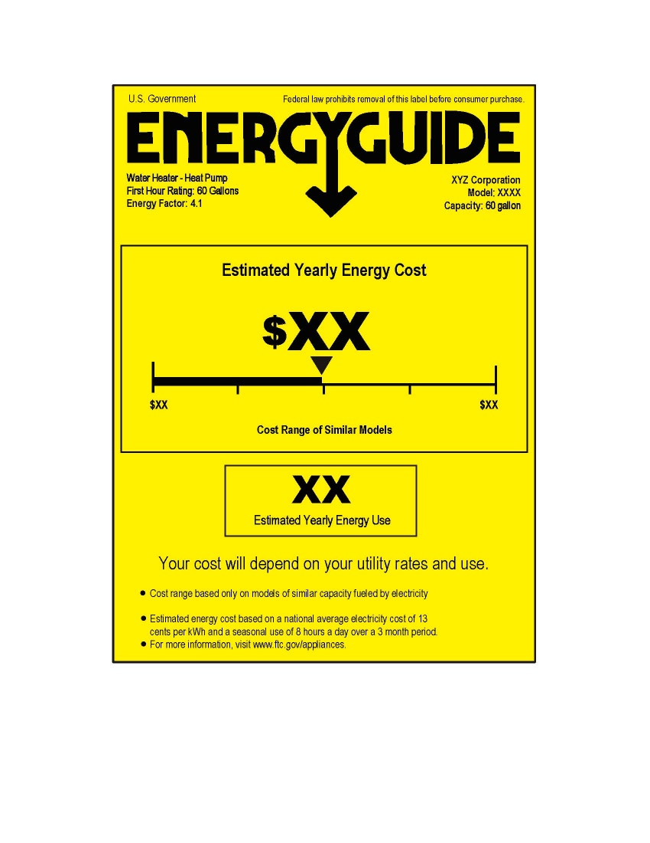

Figure 2: Example of Energy Label  
Template retrieved from: [EnergyGuide Labeling: FAQs for Appliance Manufacturers | Federal Trade Commission (ftc.gov)](https://www.ftc.gov/business-guidance/resources/energyguide-labeling-faqs-appliance-manufacturers)

**Fuel Sources of Water Heaters**   
There are multiple fuel types or energy sources for heating water, including electricity, natural gas, propane, fuel oil, solar thermal, solar photovoltaic, and geothermal. HPWHs rely on electricity to heat water. As the U.S. transitions to low- or zero-carbon sources of electricity generation, HPWHs can provide permanent load reduction relative to conventional electric resistance water heaters, and thus reduce the extent of low- or zero-carbon electricity generation required to power the U.S. building stock.

Problem Set 2.3

1. What are four different fuel types that can be used to power a water heater?
2. What information can be found on the yellow Energy Guide label of a water heater?
3. What determines a water heater’s Uniform Energy Factor?

**Learning Objective 2.4:**

* Discuss the business case for HPWHs (sellers)

**Lecture Notes 2.4:**

# References:

DOE.*Selecting a New Water Heater*. n.d. <https://www.energy.gov/energysaver/selecting-new-water-heater>.

Hot Water Solutions. *HotWaterSolutionsNW.org: Heat Pump Water Heaters Cut Electric Bills*. n.d. 2022. <https://hotwatersolutionsnw.org/>.

NEEA. "Northwest Heat Pump Water Heater Market Progress Evaluation Report #6." 2022. 2022. https://neea.org/resources/northwest-heat-pump-water-heater-market-progress-evaluation-report-6.

**Growing Market**

Energy efficiency and security (i.e., reliable access to energy) are concepts that have become more prevalent in the conscience of the general population. Additionally, climate change has increased the desire of individuals to reduce their carbon footprint. Many are seeking to upgrade appliances in their households to meet this goal. Recent laws and policies, such that support the Net-Zero Initiative, have given additional support for transitioning to energy efficient appliances such as HPWHs. This growing trend is heavily reflected in the market for water heaters where HPWHs have increased. For example, northwestern states (Washington, Oregon, Idaho, and Montana) have seen an increase in HPWH market share, from 8.5 % 2017 to 11.6 % in 2020.[1] There is a particularly strong trend in new construction where HPWHs account for 59 % of electric water heater installation. In other part of the country, such as California, standards such as Title 24 has a driven an increase in HPWH installation in new homes.[2]

**High Initial Cost and Rebates/Incentives**  
Opportunity can also be found in water heater replacement. Businesses may find a valuable market to tap into by promoting and facilitating the sale of HPWHs. While the higher price may discourage potential customers from purchasing the more efficient unit, educating customers about rebates and tax incentives could result in a larger volume of units being sold. The federal Inflation Reduction Act provides tax credits and rebates for HPWH installs. HPWH installs are eligible for a 30% tax credit, up to $2,000 for purchasing an [ENERGY STAR qualified heat pump](https://www.energystar.gov/about/federal_tax_credits/water_heaters_non_solar). Income-qualified homeowners will be eligible for rebates up to $1,750.

Rebates are also provided by some local utilities and government agencies in the form of instant, mail-in, or online rebates. Similar incentives are rarely provided for less efficient conventional units, so the likelihood of successful sales is lowered. Two examples of utility incentives can be found below.

1. American Electric Power Southwestern Electric Power Company (AEP SWEPCO):  
   [SAVING IS SIMPLE WITH SWEPCO. (swepcosavings.com)](https://swepcosavings.com/#/residential/efficient-products)
   * AEP SWEPCO offers instant rebates on the purchase and installation of HPWH. The product must meet certain requirements to receive the rebate.
     + Region: Parts of Arkansas, Louisiana, and Texas
     + Requirements: Purchase and Installation of ENERGY STAR® certified HPWH
     + Incentive: $500
2. Pacific Power:

[Heat Pump Water Heaters | Wattsmart Savings](https://wattsmartsavings.net/washington-residential/find-savings-plumbing-and-water-heating/heat-pump-water-heaters/)

* + The Pacific Power Wattsmart Home Energy Program offers incentives for the adoption of efficient HVAC, HPWH’s, and smart thermostats.
    - Region: Parts of Washington
    - Requirements:
      1. Heat pump water heater: Tier 3 and above, 0-55 gallons
      2. Self-installed heat pump water heater: Tier 3 and above, 0-55 gallons
    - Incentive:
      1. $600
      2. $900

Another factor that is just as important to securing the sale of HPWHs is the expertise of the contractor for siting and accommodating for HPWHs in homes. The more knowledgeable a contractor is on the workings and proper installation of HPWHs, the more they can apply and pass on their knowledge to customers to push through sales. The sales of HPWHs can also be affected by availability of the unit. If the HPWH is available immediately as opposed to having a significant delay time, then customers will be more likely to go with a HPWH, specially for emergency water heater replacements.

The lower annual operational cost should be emphasized and outlined as much as possible. The simple example found in 1.4 should serve as a general starting point to demonstrate the lifetime cost saving opportunity. When details are needed between different models, the calculations found on 3.1 should be used to measure the lifetime savings and number of years needed for the initial cost difference to be overcome. Because the lifetime saving opportunities of using an efficient HPWH are so pronounced, a case can be made for the early replacement of an inefficient water heater. Even without the presence of signs that indicate the need to replace an older HPWH as detailed in 1.4 (corrosion, water leakage, rust, unexpected noises, and a lack of hot water production).

Problem Set 2.4

1. What type of agencies have an interest in the widespread adoption of HWPHs, and thus offer incentives for their purchase?

1. Northwest Heat Pump Water Heater Market Progress Evaluation Report #6
2. California Energy commission: [Building Energy Efficiency Standards - Title 24 | California Energy Commission](https://www.energy.ca.gov/programs-and-topics/programs/building-energy-efficiency-standards)