Building Science Education Solution Center – Heat Pump Water Heater Business Development.

Proficiency Level 2: Understand

Learning Objective 2.1:
- Articulate what benefits of a HPWH should be communicated to a customer to facilitate a sale.
Lecture Notes 2.1:
References:

Communication
In order to increase the sales and market value of heat pump water heaters (HPWH), it is important for businesses to be able to communicate the benefits of HPWHs to the customers. Such benefits include reduced operating costs, rebate programs that reduce the initial purchasing price, additional cooling provided by the HPWH, and combustion safety. Emphasis should be placed on the lower operating costs, and how long it takes for it to offset the initial higher purchasing price of a HPWH, relative to that of a conventional gas/oil/electric water heater.
Level 2 of Introduction to Heat Pump Water Heater goes into further detail as to the general benefits of HPWHs, both financial and non-financial. Additionally, level 3 of Introduction to Heat Pump Water Heater provides tables, equations, and calculations that can be used as an example of energy and operation costs savings for the customer. A seller should be familiar with these numerical operations, so that they may communicate them effectively to potential customers.
Other benefits that can communicated to a prospective customer about HPWHs can be found below.
- Lower Operating Cost
- Available rebates and incentives
- Safer operating mechanism
- Lower greenhouse gas emissions
- Longer lifetime of the unit
- Demand response / grid interactive
Problem Set 2.1:
- What are two of the benefits of HPWH that can be communicated to the customer in order to facilitate the sale of HPWH?

Learning Objective 2.2:
- Discuss the market trends for heat pump water heaters and what causes them.

Lecture Notes 2.2:
References:
Northwest Heat Pump Water Heater Market. Progress Evaluation Report #6. 2022, Accessed 2023.
< https://neea.org/img/documents/Northwest-Heat-Pump-Water-Heater-Initiative-Market- Progress-Evaluation-Report-6.pdf>
Northwest Energy efficiency Alliance. Water Heater Market Characterization Report. 2018, Accessed 2023. < https://neea.org/img/documents/water-heater-market-characterization-report.pdf>
Northeast/Mid-Atlantic Heating Electrification. Market Transformation Progress Report. 2022, Accessed 2023. < https://neep.org/northeastmid-atlantic-heating-electrification-market-transformation- progress-report>
U.S International Trade Commission. Residential Heat Pump (Hybrid) Water Heater Market, Production, and Trade. 2022, Accessed 2023. <https://www.usitc.gov/publications/332/executive_briefings/ebot_residential_heat_pump_hy brid_water_heaters.pdf>
ENERGY STAR. Partner Resource. Accessed 2023. <https://www.energystar.gov/partner_resources/products_partner_resources/brand_owner_re sources/unit_shipment_data/archives

Market for HPWH
Businesses that aim to promote the sales of HPWH should be familiar with market trends, both nationally and locally. By doing so, they can better understand the driving factors that are increasing the adoption of HPWHs. Additionally, businesses should understand what features, qualities, and limitations most affect the sales of their own in-stock units.
National Market Trends
HPWHs have been on an upward trend in the nation. A U.S. International Trade Commission Report states that the “U.S. HPWH market doubled in the last five years, with apparent consumption of Energy Star- certified units increasing from 52,000 units in 2016 to 104,000 in 2020”. While still a small share of the overall water heater market, an upward trend signifies an opportunity for expansion of sales. In particular, these sales reflect key target audiences that businesses could identify as potential markets for which the sale of HPWHs is more likely. These target markets are:
- New home construction
- Areas where energy efficient codes and requirements have been implemented
- Regions with incentives from local utilities and manufacturers
- Customers who prefer more efficient product and/or one with a lower cost of operation
This small share of the overall market can be seen as early adopters, as HPWHs improve, they can become more prevalent in the general public. Figure 1 shows data on the overall growth and adoption of the HPWH market.

Table 1: * 2010 ENERGY STAR reported HPWH shipment data was 59,000, but included 2009 shipments.
Source: ENERGY STAR, Unit Shipment Data Annual Reports, 2010-2021
https://www.energystar.gov/partner_resources/products_partner_resources/brand_owner_resources/unit_shipment_data
Year | E* HPWHs | Elec WH Mkt Share
2009* | 22,000 | 0.59%
2010* | 37,000 | 0.99%
2011 | 23,000 | 0.62%
2012 | 34,000 | 0.91%
2013 | 43,000 | 1.07%
2014 | 46,000 | 1.08%
2015 | 55,000 | 1.37%
2016 | 52,000 | 1.32%
2017 | 72,000 | 1.74%
2018 | 65,000 | 1.54%
2019 | 84,000 | 2.00%
2020 | 104,000 | 2.23%
2021 | 112,000 | 2.29%
Total | 749,000 | 1.51%
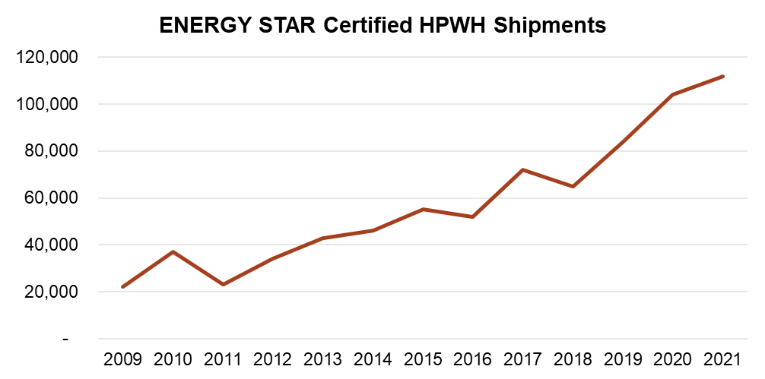
Figure 1: Energy Star Certified HPWH shipments per year.
Source: ENERGY STAR, Unit Shipment Data Annual Reports, 2010-2021
https://www.energystar.gov/partner_resources/products_partner_resources/brand_owner_resources/unit_shipment_data
Regional Market Transformation
Businesses should understand the local trends for HPWH adoption. By understanding local trends, businesses can adjust accordingly to cater to the demands of HPWHs in the area. Especially if it shows a growing trend where HPWHs continue to increase in prevalence.

For example, northwestern states (Washington, Oregon, Idaho, and Montana) have seen an increase in HPWH market share, from 8.5 % 2017 to 11.6 % in 2020. There is a particularly strong trend in new construction where HPWHs account for 59 % of electric water heater installation. In other parts of the country, such as California, standards such as Title 24 have driven an increase in HPWH installation in new homes.

Another regional market trend report can be found in “Northeast/Mid-Atlantic Heating Electrification Market Transformation Progress Report”. An example of its content includes the implementation of city and states laws that grant rebate promotions for electrification of building, including heat pumps technology for water heaters.

Different regions can vary significantly in their market growth for HPWHs, so it is important to perform additional research in order to best understand the circumstances in the local community. Doing so can benefit the business in such that they apply their resources effectively in the sales of HPWHs. Additional guidance on how to access the local HPWH market can be found on the Section 2.3 of this module.

Problem Set 2.2:
- What is an example of a regions are seeing an increase in the adoption of HPWHs?
- The national trend suggests that HPWHs are growing in market share.
  - True
  - False
Learning Objective 2.3:
- Interpret and utilize additional resources for HPWH business development.

Lecture Notes 2.3:
References:
HotWaterSolutions. WELCOME TO THE HEAT PUMP WATER HEATER RESOURCE CENTER. Accessed 2023. < https://hotwatersolutionsnw.org/partners>
Efficiency Maine. Heat Pump Water Heaters. Accessed 2023. < https://www.efficiencymaine.com/at- home/residential-forms/>.< https://www.efficiencymaine.com/at-home/water-heating- solutions/heat-pump-water-heaters/>
National association of State Energy Officials. Accessed 2023. < https://www.naseo.org/>
Additional Resources – HotWaterSolutions
A valuable source of information that aims to facilitate business development of HPWHs is provided by HotWaterSolutions partners page (HotWaterSolutionsNW.org | Partners). This site provides valuable marketing content and information for potential businesses. This content includes marketing assets, sales materials, and HPWH strategies/planning.
HotWaterSolutions offer orientations and training for installers to become more proficient in the practice of installing HPWHs, ultimately providing a more valuable service. Additionally, the website includes training presentations for sales teams and individuals.
Lastly, the website includes a comprehensive database of the technical specifications of HPWHs from leading HPWH manufacturers. This allows businesses to quickly browse and specify what HPWH units best fits the needs of their customers, ultimately providing a better service that satisfies their customers.

Additional Resources – State Specific Organizations
Searching for non-profit or state government organizations that work to promote energy use reduction by the adoption of energy efficient appliances (such as HPWHs) can yield valuable resources. These organizations often put out valuable educational information in the form of pamphlets, brochures, and videos. This educational information is often catered to serve the specific regional landscape in both climate and government. For example, different climate zones in the US may benefit to a different degree from the energy savings from HPWHs than others. While state governments may offer varying amounts of incentives for energy efficient appliance adoptions, which would require state specific paperwork/procedure to claim.
An example of such an organization is Efficiency Maine Trust. From their own description, “The Efficiency Maine Trust (Efficiency Maine) is the independent, quasi-state agency established to plan and implement energy efficiency programs in Maine”. Their educational content for HPWHs includes heat Pump water heater rebate claim forms, user tips, myths, and facts, testimonials from plumbers, prices, and discount brochures. This content can be used by businesses to bolster their sales of HPWHs by passing forward their educational content to potential customers at no additional costs. Lastly, they have tools for prospective customers to search for nearby vendors of desired energy efficient vendors. It would be beneficial for businesses to increase their visibility by becoming a registered vendor and becoming searchable in these databases.
While Efficiency Maine operates in the state of Maine, similar entities operate across the U.S. that serve their particular regions. It takes effort from the businesses to find these organizations. The National Association of State Energy Officials (NASEO) provides an interactive map/database that can help find your state’s energy offices and organizations. State energy offices will generally provide information and links to energy related events, promotions, and organizations that promote energy efficient appliances (such as Efficiency Maine).

Problem Set 2.3:
- What website can be used to help located non-profit, or state government organizations that promote energy efficient technologies via a number of techniques that include, but not limited to information on rebate programs, searchable registry, and educational content for businesses?
- Using the information in this section, find an organization that promotes energy efficient appliance adoptions, and serves your local area or state.

Residential Heat Pump (Hybrid) Water Heater Market, Production, and Trade
Northwest Heat Pump Water Heater Market Progress Evaluation Report #6
California Energy commission: Building Energy Efficiency Standards - Title 24 | California Energy Commission
Northeast/Mid-Atlantic Heating Electrification Market Transformation Progress Report
Efficiency Maine | Saving energy, reducing energy costs, and improving energy conservation
Maine Home Energy Upgrade Forms & Checklists | Efficiency Maine
Find a Residential Registered Maine Energy Vendor | Efficiency Maine
Residential Registered Vendors - Efficiency Maine

