Building Science Education Solution Center – Linear Interpolation
Proficiency Level 3: Apply
Learning Objective 3.1:
- Calculate the formula for linear interpolation
- Apply linear interpolation to HVAC equipment sizing
Lecture Notes 3.1
Linear interpolation can be used to determine an unknown value when at least two other points in a linear relationship are known. This means that if two points on a line are known, any point in between can be found.

Consider the case of sizing an HVAC system. If a unit’s capacity at a specific design temperature is not specified, linear interpolation can be used to estimate output at that temperature. As an example, assume a contractor is considering the heat pump whose extended performance data are shown in Table 1.
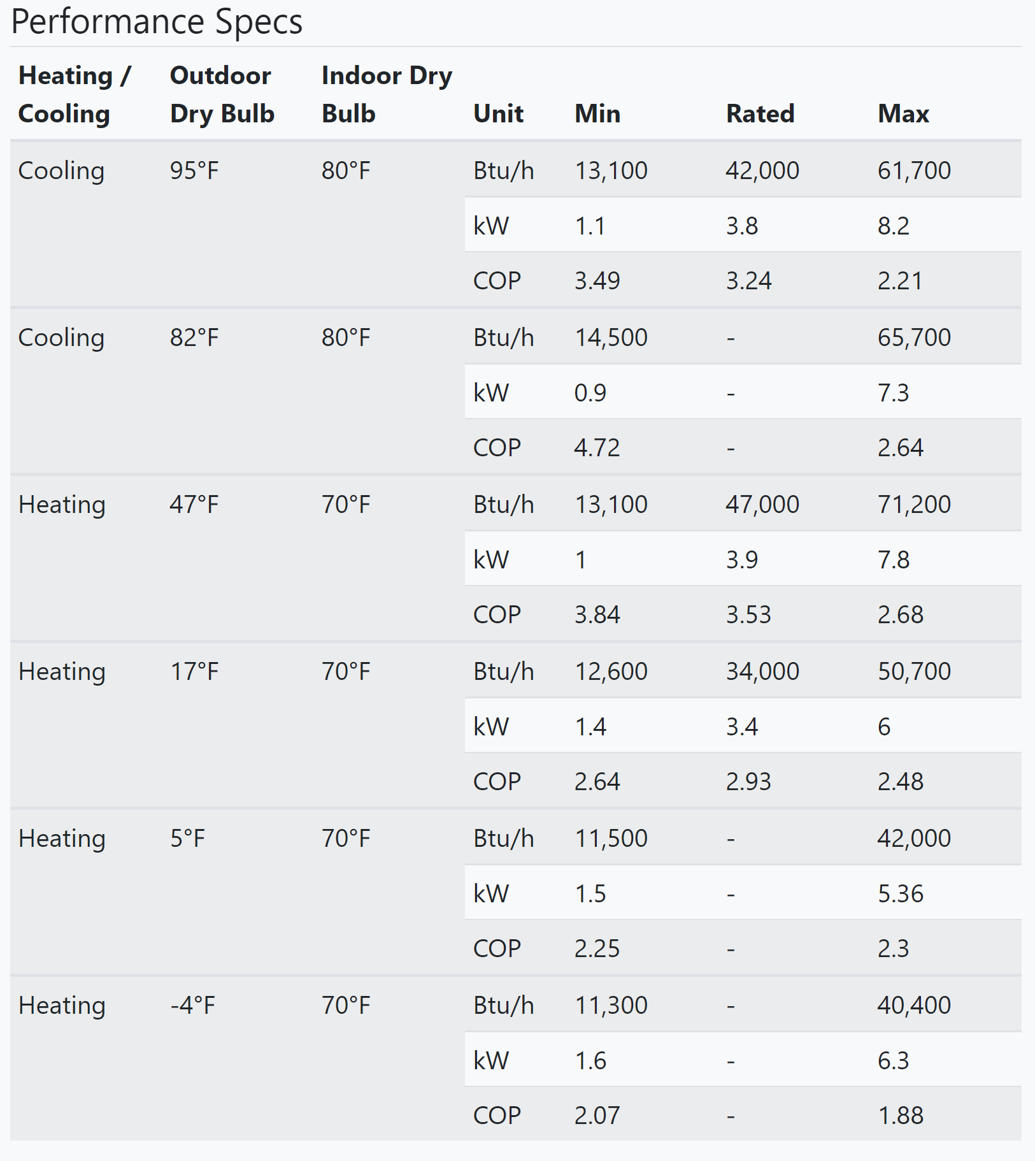
Table 1: Variable capacity heat pump performance data (Courtesy of NEEP)
If the local heating design temperature is 0°F/-17.8°C, the contractor cannot get the unit’s capacity directly from the table. However, the contractor knows the capacity at 0°F will be between the capacity at 5°F/-15°C and the capacity at -4°F/-20°C, both of which are listed in the table. The contractor will need to use linear interpolation.
In Figure 1 the blue dots represent the known capacities at two known temperatures. By drawing a line between them, the missing value can be found. Simply locate the desired x-coordinate (design temperature) and determine the corresponding y-coordinate (heating capacity) along the line. The orange dot represents this interpolated value of the heating capacity at 0°F/-17.8°C. From this graph, we can see that the heating capacity at 0°F/-17.8°C is approximately 41,100 Btu/hr.

Figure 1: Linear interpolation of heating capacity between two temperatures

Calculating the answer using a formula will give the exact result. The formula for linear interpolation is shown below. The two known points are (x₁, y₁) and (x₂, y₂). The unknown value is y for some value x. Evaluating the formula for a chosen value of x on the line (i.e. in between x₁ and x₂) will result in y.
$$y=y_{1}+\left(y_{2}-y_{1}\right)\frac{(x-x_{1})}{{(x}_{2}-x_{1})}$$ | (1)

The following example is calculated using °F but can be made using corresponding °C. Applying Equation (1) to the example above, y represents the unknown heating capacity at the design temperature 0°F. Value x is the design temperature (0°F). Values x₁ and x₂ are -4°F and 5°F respectively. Values y₁ and y₂ are the max heating capacities at -4°F and 5°F, as listed in the table. See the completed equation below.

$$y=40,400 Btu/hr+\left(42,000 Btu/hr-40,400 Btu/hr\right)\frac{\left(0°F - -4°F \right)}{\left(5°F - -4°F \right)}$$ | (2)
$$y=40,400 Btu/hr+\left(1,600 Btu/hr\right)*\frac{4}{9}$$ | (3)
$$y=40,400\frac{Btu}{hr}+ 711 Btu/hr$$ | (4)
$$y=41,111 Btu/hr$$ | (5)

The contractor has interpolated the heating capacity at 0°F/-17.8°C as 41,111 Btu/hr. Now check to see if this answer matches the value of the orange dot in the visualization above. This kind of calculation can be performed if there is data available for temperatures above and below the design temperature. It can also be performed to find cooling output at design temperatures different from those provided. If there are only data points either greater or less than the desired temperature, a similar process called extrapolation would be used. However, this may not hold valid for the case of sizing HVAC equipment and is not recommended.

Problem Set 3.1
- What is the main function of linear interpolation?
  - Creating a linear relationship between two points
  - Determining an unknown value on an existing line between two known points
  - Extending a linear relationship beyond known data to predict the line’s behavior
  - Making a graph for a report
- A heat pump has the following output capacity at standard rated temperatures: 36,000 Btu/hr at 47°F and 20,000 Btu/hr at 17°F. The design heating load of the home is 22,000 Btu/hr at 22°F. Determine the output capacity of the heat pump at the design temperature and if it is sufficient for this home.

