# Primary Window Components

Glazing technology is combined with a spacer system and a gas fill between the panes to produce an energy-efficient Insulating Glass Unit (IGU). An IGU is assembled with frame and operability options to form the complete window assembly. Some integrated technological innovations that appear in today’s fenestration products are listed below.

• Multiple layers of glass or plastic film

• High performance glazing low-e or solar control coatings

• Low-conductance gas fills

• Warm edge spacers

• High performance frames

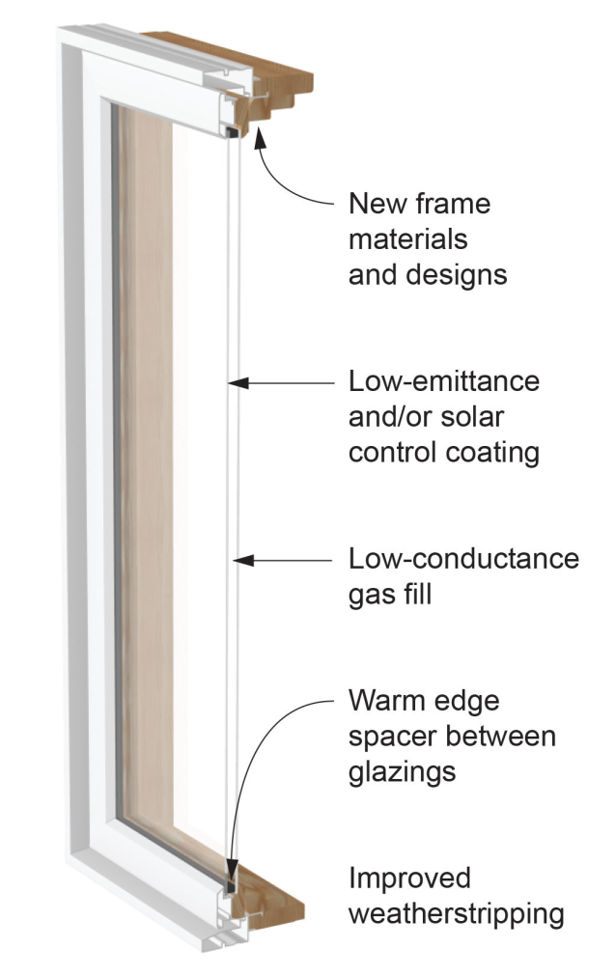

**Figure 1** Energy Efficient Window Components

A variety of window technologies can improve window energy efficiency, including gas fills, low-E coatings, and high-performance frame options. How these technologies affect a window's energy performance depends on the sum of all parts. This is where whole window energy ratings help, accounting for the combined effect of glazing, spacers and frame (thermally improved). The only reliable way to determine whole-window energy properties are the ratings certified by the National Fenestration Rating Council (NFRC). In most jurisdictions across the United States, building energy codes require that windows bear the NFRC label so that the code compliance of their energy ratings can be verified.

The following picture shows the energy efficient window components along with the other window assembly components that may be important in installation.

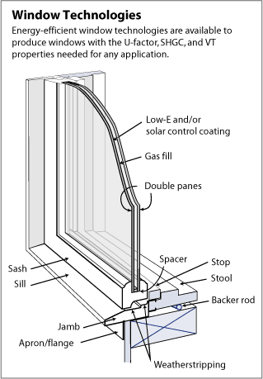

The following content describes the details of each component of a window assembly.

## Frame Types

Metal FramesAluminum is light, strong, durable, and easily extruded into the complex shapes required for window parts. Aluminum window frames are available in anodized and factory-baked enamel finishes that are extremely durable and low maintenance. The biggest disadvantage of aluminum as a window frame material is its high thermal conductance. It readily conducts heat, greatly raising the overall U-factor of a window unit. In cold climates, a simple aluminum frame can easily become cold enough to condense moisture or frost on the inside surfaces of window frames. This condensation problem, even more than heat loss, has spurred the development of better insulating aluminum frames. In hot climates, where solar gain is often more important than conductive heat transfer, using a higher performance glazing system can be much more important than improving the insulating value of the frame.

Thermally Broken Metal FramesThe most common solution to the heat conduction problem of aluminum frames is to provide a “thermal break” by splitting the frame components into interior and exterior pieces and use a less conductive material to join them (see Figures 13 and 14). Current technology with standard thermal breaks has decreased aluminum frame U-factors (heat loss rate) from roughly 2.0 to about 1.0 Btu/h∙ft2∙°F.

Nonmetal Frames

Wood

The traditional window frame material is wood, because of its availability and ease of milling into the complex shapes required to make windows. Wood is favored in many residential applications because of its appearance and traditional place in house design (see Figure 15). From a thermal point of view, wood-framed windows perform well with frame U-factors at 0.3– 0.5 Btu/h∙ft2∙°F. Wood is not intrinsically the most durable window frame material, because of its susceptibility to rot, but well-built, well-protected, and well-maintained wood windows can have a very long life.

Wood Clad

A variation of the wood-framed window is to clad the exterior face of the frame with either vinyl or aluminum, creating a permanent weather-resistant surface. Clad frames thus have lower maintenance requirements and retain the attractive wood finish on the interior (see Figure 16). Although vinyl and enameled metal claddings offer much longer protection to wood frames, they are generally available in limited colors.

#### Vinyl

Vinyl, also known as polyvinyl chloride, is a very versatile plastic with good insulating value. Vinyl window frames do not require painting and have good moisture resistance (see Figure 17). Because the color goes all the way through, there is no finish coat that can be damaged or deteriorate over time—the surface is therefore maintenance free. Some vinyl window manufacturers now offer surface treatments such as laminates (wood veneer, paintable/stainable, maintenance free) and coatings. These products increase color selection and surface appearance options. Recent advances have improved dimensional stability and resistance to degradation from sunlight and temperature extremes. The thermal performance of vinyl frames is comparable with that of wood, although there are minor differences (depending on the frame construction). Small hollow chambers within the frame reduce convection exchange, as does adding an insulating material (see Figure 18).

#### Hybrid

Manufacturers are increasingly turning to hybrid frame designs that use two or more frame materials to produce a complete window system. The wood industry has long built vinyl-and aluminum-clad windows to reduce exterior maintenance (see Figure 19). Vinyl manufacturers and others offer interior wood veneers to produce the finish and appearance that many homeowners desire. Split-sash designs may have an interior wood element bonded to an exterior fiberglass element.

#### Composite

Wood particles and resins can be compressed to form a strong composite material. Window frame and sash members can be manufactured from wood/polymer composites that have been extruded into a series of lineal shapes. These composites are very stable, and have the same or better structural and thermal properties as conventional wood, with better resistance to moisture and decay. They can be textured and stained or painted much like wood.

#### Thermally Improved or Insulated Vinyl

Thermally improved windows may include a combination of features resulting in a lower U-factor, such as high performance frame design and low conductance spacers in combination with high performance glazing. Although the thermal performance of most vinyl frames is comparable to that of wood, they can be further improved by creating smaller chambers in the frame, reducing the convection exchange that can occur in large hollow chambers. Often these hollow cavities are filled with an insulating material. Usually, these high-performance frames are used with high performance glazing.

As with standard vinyl frames, thermally improved or insulated vinyl frames do not require painting and have good moisture resistance. Because the color goes all the way through, there is no finish coat that can be damaged or that will deteriorate over time. Recent advances have improved dimensional stability and resistance to degradation from sunlight and temperature extremes.

#### Fiberglass or Engineered Thermoplastics

Window frames can be made of glass-fiber-reinforced polyester (fiberglass) or engineered thermoplastics that are pultruded into lineal forms and then assembled into windows. These frames are dimensionally stable and have air cavities (similar to vinyl). The frame cavities can be filled with insulation or designed with multiple small chambers to reduce convection exchange. Because these materials are stronger than vinyl, the frames can have smaller cross-sectional shapes and thus less area, and are therefore particularly well suited to hold heavier triple glazing. Usually, these high-performance frames are used with high performance glazing.

#### Thermally Improved Wood and Composite Frames

Wood-framed windows have frame U-factors of 0.30–0.50 Btu/h∙ft2∙°F. Although the absence of frame cavities limits the options to further boost wood frame insulating value, thermal improvements can be achieved through thicker frame design, by avoiding thermal shortcuts through metal parts, and with low conductance spacers.

## Glazing

Glazing is another word used to describe glass that is in a window assembly. The number of glass layers, various coatings, tints, and other glass surface treatments can affect the energy properties of windows.

Multiple layers of glass or plastic films improve thermal resistance and reduce the heat loss attributed to convection between layers. Double glazing reduces heat loss (as reflected by the U-factor) by more than 50% compared to single glazing. Although U-factor is reduced significantly, the VT and SHGC for a double-glazed unit with clear glass remain relatively high. Adding a third layer of glass reduces the VT and SHGC. Adding a low-e coating to a surface, or to multiple surfaces, will increase energy performance. Depending on the type of low-e coating, the SHGC and VT will also be affected.

Additional panes of glass increase the weight and thickness of the unit, which makes mounting and handling more difficult and transportation more expensive. There are physical and economic limits to the number of glass panes that can be added to a window assembly. However, multiple-pane units are not limited to glass assemblies, but can be made up of one or more layers of suspended film.

## Gas Fill

The various layers of glazing layers are assembled in an IGU. A possible improvement to the thermal performance of an IGU is to reduce the conductance of the air space between the layers by using a gas fill and low-conductance spacers that control the properties of the spaces between the layers.

With the use of a low-e coating, heat transfer across a gap is dominated by conduction and natural convection. Air is a relatively good insulator, but other gases (such as argon, carbon dioxide, krypton, and xenon) have lower thermal conductivities. Using one of these nontoxic gases in an IGU can reduce heat transfer between the glazing layers. In a sealed IGU, air currents between the two panes of glazing carry heat to the top of the unit and settle into cold pools at the bottom. The air in the space between the panes can be replaced with a less conductive and more viscous (slower moving) gas. This replacement minimizes the convection currents in the space, which reduces conduction through the gas and the overall transfer of heat between the inside and outside.

Manufacturers generally use argon or krypton gas fills, with measurable improvement in thermal performance. Both gases are inert, nontoxic, nonreactive, clear, and odorless. Krypton has better thermal performance than argon and is more expensive to produce. The optimal spacing for an argon-filled unit is the same as for air, about ½ in􀁆􀁋. Krypton performs better than argon when the space between glazing must be thinner than normally desired (for example, ¼ in.), but it is more costly. A mixture of krypton and argon gases is sometimes used as a compromise between thermal performance and cost. Argon and krypton occur naturally in the atmosphere, but maintaining long-term thermal performance is certainly an issue. Studies have shown less than 0.5% leakage per year in a well-designed and well-fabricated unit, or a 10% loss in total gas over a 20-year period. The overall effect of a 10% gas loss would change the U-factor by only a few percentage points. Keeping the gas within the glazing unit depends largely on the quality of the design, materials, and, most important, assembly of the glazing unit seals.

Though there are a number of gasses used (such as Argon, Krypton, Xenon, and others), and each window manufacturer may have its own proprietary formula, all are chosen for the increased ability of the gas (compared to normal air) to insulate the window. (The gasses used are odorless and harmless should the window break.)

In addition to the gas fill, window glass may be treated to further increase the energy efficiency of the window. There have been significant technological developments involving low-emissivity (low-E) coatings on the glass. There are many glass products available with low-E coatings, which are typically used with multiple-pane insulating glass units.

Emissivity is the ability of a product's surface to reflect heat back into a room during a cold winter day or to keep the heat outside on a hot summer day. A product with high emissivity, such as a clear piece of glass, will allow over 84% of the infrared energy from a warm room outside to the cold air. The lower the emissivity of the glass, the lower the rate of heat loss and the lower the U-factor.

## Coatings

All materials, including windows, emit (or radiate) heat in the form of long-wave, far-infrared energy depending on their temperature. This emission is one of the important components of window heat transfer, so reducing the window’s emittance can greatly improve its insulating properties. Coating a glass surface with a low-e material and facing that coating into the gap between the glazing layers blocks a significant amount of this radiant heat transfer, lowering the total heat flow through the window. When heat or light energy is absorbed by glass, it is either convected away by moving air or reradiated by the glass surface. The ability of a material to radiate energy is called its *emissivity*.

Low-emissivity (Low-e) coatings are highly transparent and virtually invisible, but have a high reflectance to long-wavelength infrared radiation. This reduces long-wavelength radiative heat transfer between glazing layers by a factor of 5–10, thereby reducing total heat transfer between two glazing layers. Low-e coatings may be applied directly to glass surfaces, or to suspended films between the interior and exterior glazing layers.

The solar reflectance of low-e coatings can be manipulated to include specific parts of the visible and infrared spectrum. This is the origin of the term *spectrally selective coatings*, which selects specific portions of the energy spectrum so desirable wavelengths of energy are transmitted and others specifically reflected. A glazing material can then be designed to optimize energy flows for solar heating, daylighting, and cooling.

Standard clear glass has an emittance of 0.84 over the long-wave portion of the spectrum, meaning that it emits 84% of the energy possible for an object at its temperature. It also means that 84% of the long-wave radiation striking the surface of the glass is absorbed and only 16% is reflected. By comparison, low-solar-gain low-e glass coatings can have an emittance as low as 0.04. Such glazing would emit only 4% of the energy possible at its temperature, and thus reflect 96% of the incident long-wave, infrared radiation. Window manufacturers’ product information may not list emittance ratings. Rather, the effect of the low-e coating is incorporated into the U-factor and SHGC for the unit or glazing assembly.

### High-Solar-Gain Low-Emittance Coatings

High-solar-gain low-e coatings typically have an SHGC value greater than 0.40 and are designed to reduce heat loss but admit solar gain. High-solar-gain products are best suited to buildings located in heating-dominated climates and particularly to south-facing windows in passive solar designs. Unless properly shaded, high-solar-gain windows may result in overheating from excess solar gain in swing seasons (see Figure 9).

### Moderate-Solar-Gain Low-Emittance Coatings

Moderate-solar-gain low-e coatings typically have an SHGC value of 0.25–0.40. Such coatings reduce heat loss, maintain high light transmittance, allow a reasonable amount of solar gain, and are suitable for climates with heating and cooling concerns.

### Low-Solar-Gain Low-Emittance Coatings

Low-solar-gain low-e coatings typically have an SHGC value less than 0.25. This type of low-e product, using a highly spectrally selective low-e glass, reduces heat loss in winter and reduces heat gain in summer. Compared to most tinted and reflective glazing, this low-e glass transmits visible light, but blocks a large fraction of the solar infrared energy, thus reducing cooling loads.

### Coating Placement

The placement of a low-e coating within the air gap of a double-glazed window does not affect the U-factor, but it does influence the SHGC. Thus, in heating dominated climates, placing a low-e coating on the #3 surface (outside surface of the inner pane) is recommended to maximize winter passive solar gain at the expense of a slight reduction in the ability to control summer heat gain. In cooling climates, a coating on the #2 surface (inside surface of the outer pane) is generally best to reduce solar heat gain and maximize energy efficiency. Manufacturers sometimes place the coatings on surfaces for other reasons, such as minimizing the potential for thermal stress (e.g., #2 surface in a heating climate). Multiple low-e coatings are also placed on surfaces within a triple-glazed window assembly, or on the inner plastic glazing layers of multipaned assemblies, which further improves the overall U-factor.

## Spacers

Heat transfer through the metal spacers that are used to separate glazing layers can increase heat loss and cause condensation to form at the edge of the window. “Warm edge” spacers use improved materials and better designs to reduce this effect.

The glass panes in an IGU must be held apart at the appropriate distance by spacers. In addition to keeping the glass lights separated, the spacer system must serve a number of functions:

• Accommodate stress induced by thermal expansion and pressure differences.

• Provide a moisture barrier that prevents passage of water or water vapor that would fog the unit.

• Provide a gas-tight seal that prevents the loss of any special low-conductance gas in the air space.

• Create an insulating barrier that reduces the formation of interior condensation at the edge.

The traditional approach for IGUs is to use metal spacers and sealants. These spacers, typically aluminum, also contain a desiccant that absorbs residual moisture. The spacer is sealed to the glass lights with organic sealants that provide structural support and act as a moisture barrier. There are two generic systems for such IGUs: a single-seal spacer and a dual-seal system. Unfortunately, aluminum is an excellent conductor of heat, and the aluminum spacer used in traditional edge systems represents a significant thermal “short circuit” at the edge of the IGU, which reduces the benefits of improved glazing. In addition to the increased heat loss, the colder edge is more prone to condensation. To overcome these problems, warm edge spacers are now used in more than 90% of new windows.

Innovative edge systems have been developed to address these problems, including solutions that depend on material substitutions as well as new designs. One approach to reducing heat loss has been to replace the aluminum spacer with a metal one that is less conductive (e.g., stainless steel), and change its cross-sectional shape. These designs are widely used in windows today.

Another approach is to replace the metal spacer with a design that uses materials that are better insulators. The most commonly used design incorporates spacer, sealer, and desiccant in a thermoplastic compound that contains a blend of desiccant materials and incorporates a thin, fluted metal shim of aluminum or stainless steel. Another approach uses an insulating silicone foam spacer that incorporates a desiccant and has a high-strength adhesive at its edges to bond to glass. The foam is backed with a secondary sealant. Extruded vinyl and fiberglass spacers have also been used in place of metal designs.

Several hybrid designs incorporate thermal breaks in metal spacers or use one or more of the elements described above. Some are specifically designed to accommodate three- and four-layer glazing or IGUs incorporating stretched plastic films. All are designed to interrupt the heat transfer pathway at the glazing edge between two or more glazing layers (see Figure 11).



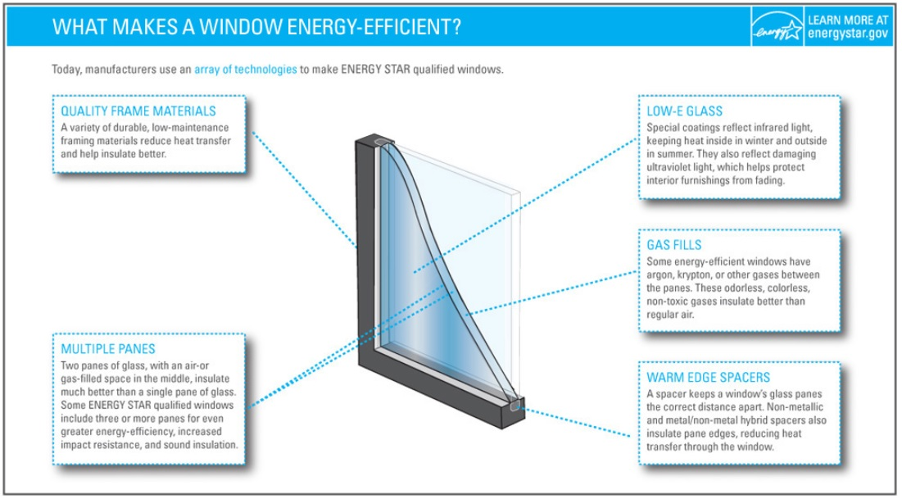

Image Source: https://www.energystar.gov/products/building_products/residential_windows_doors_and_skylights/key_product_criteria#commonProdFeatures