Building Science Education Solution Center – Introduction to Heat Pumps

Proficiency Level 2: Understand

Learning Objective 2.1:

- Understand how a heat pump moves heat

Lecture Notes 2.1:

Air source heat pumps work by utilizing the vapor compression cycle of a refrigerant, the same cycle that a refrigerator uses. The basic components of a heat pump are the compressor, the indoor coil, the outdoor coil, the expansion valve, and the reversing valve. Refrigerant flows through each of these components in a continuous cycle, powered by the compressor.

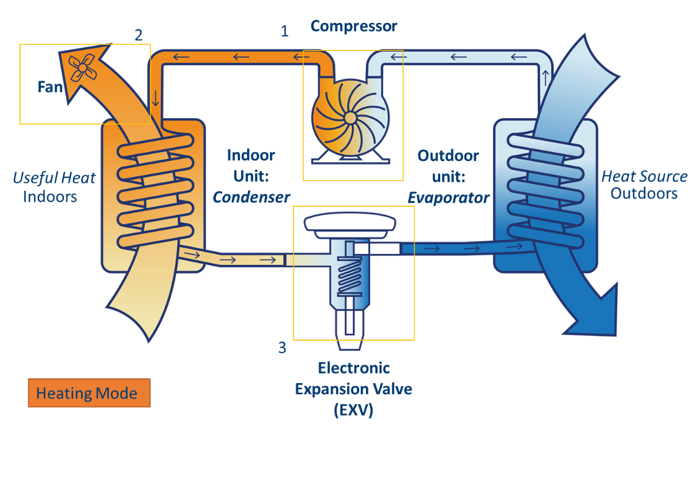
The compressor compresses and pressurizes the refrigerant, making it hotter. When the unit is in heating mode, the hot refrigerant flows to the indoor coil where it heats the supply air to the house. The refrigerant then flows to the expansion valve, which expands and depressurizes the refrigerant, making it cold. The cold refrigerant flows to the outdoor coil where it can pick up heat from the outdoor air. Finally, the refrigerant flows back to the compressor to continue the cycle. In cooling mode, the refrigerant flows in the opposite direction such that the indoor coil gets cold while the outdoor coil gets hot. The reversing valve is what directs the refrigerant to flow in a heating cycle or a cooling cycle. This component is the primary difference between a heat pump and a normal air conditioner.

The final major components of the heat pump system are the indoor fan and the outdoor fan. The outdoor fan blows air across the outdoor coil, and the indoor fan blows air across the indoor coil. This heats or cools the air. The air which is heated or cooled by the indoor coil is blown directly into the space being conditioned, most often distributed by a network of ducts.

Because air source heat pumps rely on outdoor air as the source of heat, their heating capacity is highly dependent on the outdoor air temperature. The colder the outdoor air is, the less is the amount of heat available for the heat pump to extract, and the lower is its heating capacity.

In most locations in the U.S., the outdoor air temperature can get low enough that the heat pump cannot provide the full amount of heat needed by the home. To address this issue, heat pumps can be installed with an auxiliary heat source (sometimes called emergency heat). This could be an electric resistance heating coil (also called strip heat) located in the indoor unit downstream of the heat pump’s indoor coil. Auxiliary heat could also be provided by a fossil fuel, as is done in a type of heat pump called a dual fuel heat pump. Dual fuel heat pumps are electric heat pumps which typically use natural gas or propane for auxiliary heat rather than electricity.

Auxiliary heat is not just activated when the outdoor temperature is low. It can also be activated if the thermostat setpoint is increased and the heat pump takes a long time to reach the new set point. The auxiliary heat will then come on to speed the increase in space temperature. Because auxiliary heat is usually much less efficient than heat pump heat, it is generally more energy efficient to limit its usage. This can make efficiency strategies such as night time temperature setback problematic, because in the morning when the thermostat is turned back up, the auxiliary heat will activate and negate the efficiency gains of the night time setback. For this reason, it is often recommended to simply set the thermostat at one temperature and leave it alone. A separate strategy which is often employed (and required by many codes) is to control the auxiliary heat such that it cannot activate until the outdoor air temperature is below a particular threshold (commonly around 35°F). Further discussion of thermostat control of heat pumps is located in the Smart Thermostats module.

Problem Set 2.1:

- Which of the following components are in both heat pumps and air conditioners?

- Compressor
- Indoor coil
- Expansion valve
- All of the above

- Why do some heat pumps have auxiliary heat?

- Auxiliary heat is more efficient
- Heat pumps sometimes need assistance in very cold outdoor conditions or with a very large temperature difference between the current indoor temperature and the set point
- Heat pumps are never installed with auxiliary heat
- Electric, gas or oil-based auxiliary heat still works if there is a power outage

Learning Objective 2.2:

- Understand the different types of heat pumps.

Lecture Notes 2.2:
Whole Home Heat Pumps
Several types of heat pumps are available to use. The first category is a whole-home heat pump. This system typically consists of an outdoor unit connected by refrigerant lines to an indoor air handler. The outdoor unit is commonly called a condenser unit, condensing unit, or condenser. The air handler pulls air from return ductwork or pathways and blows air through supply ductwork into each area of the home. These systems must be installed by a licensed HVAC technician as the refrigerant used in these systems must be carefully installed.
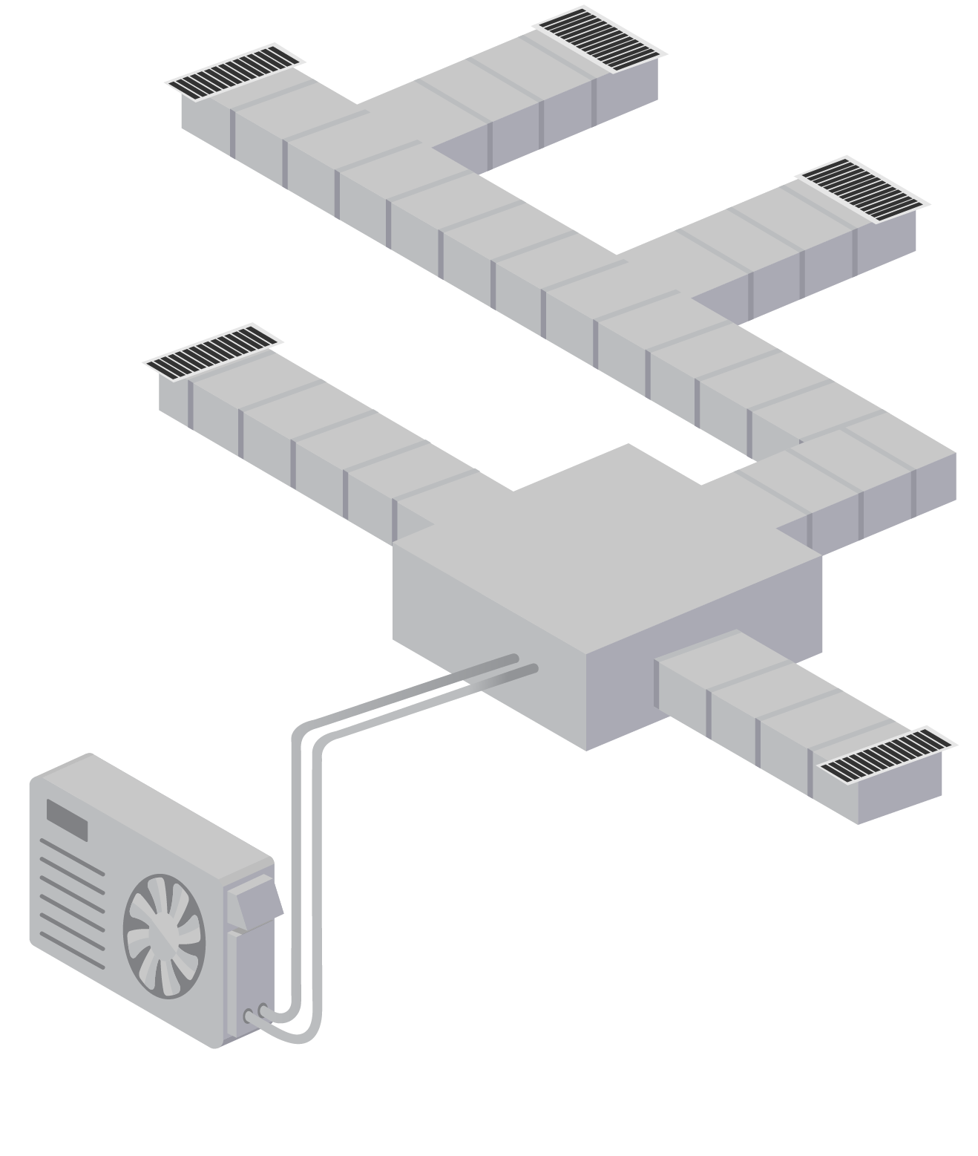

Ductless Mini-Splits/Heat Pumps
Ductless mini-splits are typically smaller heat pump systems meant for single zones. A mini-split consists of an outdoor condenser unit connected by refrigerant lines to an indoor unit, typically installed on a wall or in a dropped ceiling. The indoor unit draws air directly from the space and blows it directly into the space with no ductwork. These systems are usually higher efficiency than whole-house systems.
Multi-zone ductless heat pumps are similar to mini-splits, except that several indoor units share the same outdoor unit. These systems can be useful for homes without central ductwork or where the existing ductwork is too small.
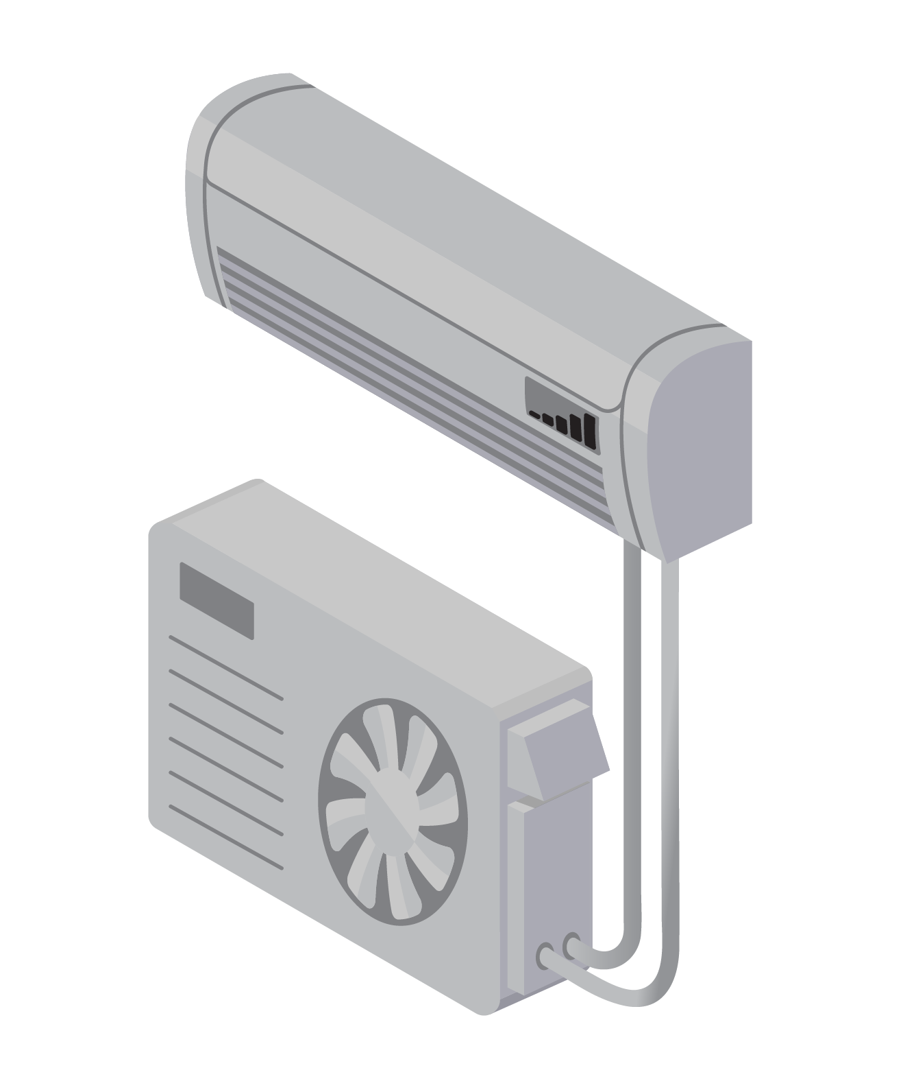
Packaged terminal heat pumps
Packaged terminal heat pumps are a single unit that passes through the wall of a home. The operation is similar to a mini-split, where the indoor side recirculates air from the immediate area. These systems are a single factory-assembled unit and do not require an on-site refrigerant charge, which makes them easier to install, however they require creating a large hole in the building wall.

Learning Objective 2.3:

- What are the different heat pump options when looking for alternatives for homes that are currently heated by a gas furnace or boiler?

Lecture Notes 2.3:

When considering upgrading to an air-source heat pump (ASHP) from an existing fossil fuel-based heating system, it is essential to consider the primary goal of the upgrade and best ASHP solution for the application. Generally, there are two primary approaches when fuel switching in residential space heating systems: replacing the whole HVAC system (“replacement heating”) or installing an ASHP to displace some or most of the heating loads while still retaining the existing fossil-based system as the backup (“displacement heating”).
Replacement Heating
Replacing the whole HVAC system with an ASHP that can carry all of the load is quite common in warmer climates, especially if the furnace and an existing air conditioner need replacement around the same time. In this case, the size of the equipment should be determined based on typical Manual J load calculations that are otherwise taught in HVAC training courses. With the increasing availability of cold climate heat pumps, switching to heat pumps is feasible in many colder areas in the United States as well. See the Cold Climate Heat Pump Sizing Module for more information.
Displacement Heating
Depending on the scope of the HVAC upgrade and the climate zone the house is in, an existing fossil-based heating system may be retained as a backup heating system. In this case, the heat pump is the primary heating system that has operational priority. In other words, the heat pump is called on first to address the heating demand. If the heat pump is unable to provide adequate heating, such as during especially colder outdoor air temperatures, the backup system is called on to provide supplemental heating. Integrated automated controls ensure that the heating load is optimized between the heat pump and the fossil-based backup system. The Smart Thermostats and Dual Fuel Controls Module covers this subject in more detail.
Another type of displacement method is installing a mini-split or other system to serve one portion of the home. This unit could be installed to help improve comfort in unbalanced or sensitive areas of the home. When two separate systems are in use, make sure to coordinate the control of the system so they do not work against each other. Often this means setting both systems to either “heat-only” or “cool-only” at the same time. When possible, the more efficient heat pump should be prioritized.

Problem Set 2.3:

- A homeowner would like to add cooling to two offices in their 3,000 SF home with natural gas boiler. What is the best option for a heat pump in this scenario?
  - Replace an existing ducted furnace system with a ducted heat pump
  - Install a heat pump as the primary heating system but keep the existing furnace or boiler as backup
  - Install a ductless heat pump system in the offices
- A homeowner is looking to replace their air conditioner in the mixed humid or hot-humid climate. They currently have a gas furnace as well. Which type of heat pump makes the most sense for this homeowner?
  - Replace an existing ducted furnace system with a ducted heat pump
  - Install a heat pump as the primary heating system but keep the existing furnace or boiler as backup
  - Install a multi-zone ductless heat pump system

Learning Objective 2.4:

- Understand the market trends for heat pumps and the benefits of switching to heat pumps in existing homes

Lecture Notes 2.4:

Electrification
An important driver behind the installation of heat pumps in new homes is the nationwide trend toward electrification of buildings and fuel switching from fossil fuels to electricity. In general, fuel switching is the process of replacing fossil-fuel fired end uses in buildings (e.g. heating, water heating, cooking and laundry drying to electric end uses) For this lesson, fuel switching (or electrification) more specifically refers to the installation of an electric heat pump to replace or supplement an existing gas, oil, propane, or coal furnace or boiler.
A primary motivation behind fuel switching is the mitigation of climate change. Fossil fuels inherently are carbon-intense to create and release carbon dioxide and other harmful byproducts into the atmosphere. Moving forward, the electric grid continues to create less and less carbon dioxide and harmful byproducts due to renewable technologies (e.g. solar and wind generation) and nuclear power plants. Therefore, the more end uses that can be converted to electricity, the more likely our buildings will be able to operate in a carbon-neutral environment in the future.
Increased Efficiency
Often the motivation to install an ASHP is to increase efficiency and reliability by replacing an aging, inefficient system. About 30% of households that use heating and about 16% of households that use air conditioning have equipment that is 15 years old, or older – meaning that 16.5 to 33.7 million households use space conditioning equipment that is at or nearing the end of its life expectancy.
Heating and cooling needs account for 50% or more of a household’s energy use, on average. Depending on the current equipment, efficiency upgrades can reduce energy use by 20% or more. This reduction will be the largest on homes with outdated, broken, or improperly sized equipment. Installation practices can majorly influence efficiency and cost effectiveness.
ASHPs are three to four times more efficient than traditional fossil fuel equipment: typical gas furnaces have a COP of 0.8 while typical heat pumps have a COP of 2-5. In many cases heat pumps can also reduce operating costs of a home’s heating system since they are so much more efficient than fossil-fuel or electric resistance systems. However, there are climate, home location, and current system considerations that will impact the efficiency, effectivity, and feasibility of installing a heat pump, especially in retrofit situations.
Improved Comfort
Sometimes homeowners want to add air-conditioning to a house that doesn’t have cooling, and choose to install a heat pump rather than to add an air-conditioner to their existing furnace or boiler system. Heat pumps are a common choice when choosing a system for an addition or retrofit – They are available in small capacities well suited to additions, and the ductless versions are excellent for areas with space constraints as is often the case with retrofits (it can be difficult to find space for duct work if a space wasn’t originally designed for it).
New Availability for Cold Climates
One factor in the increase in heat pump installations is the fact that heat pumps appropriate for use in very cold areas are now available. Historically heat pumps had only been able to provide sufficient heating when it was moderately cold outside, so heat pumps were only installed in warm to moderate climates. However, the availability of new cold climate heat pumps makes it possible and attractive for homeowners in colder areas to install a heat pump as well.
Heat pumps can also reduce safety and health concerns associated with fossil-fuel leakage including reducing or eliminating the potentially deadly byproducts of fuel combustion such as carbon monoxide.

Problem Set 2.4:

- Explain three benefits of air source heat pumps compared to fossil fuel heating systems

Learning Objective 2.5:

- Understand the business case for ASHP installation services

Lecture Notes 2.5:

As national trends toward electrification drive increased demand for ASHPs, businesses are expanding into offering ASHPs instead of just fossil fuel furnaces. This expanded offering can provide additional business opportunities maintaining and installing both heating and cooling systems. Additionally, existing customers have several potential reasons to install a heat pump before the typical end of life of their existing equipment. Customers wishing to install additional heating or cooling capacity, or to replace their existing system with lower cost or lower carbon heat pumps, will bring in more sales and maintenance.

As part of this expansion, some utilities are offering incentives in the form of rebates for their residential and/or commercial customers to install energy efficient ASHPs. This can involve changing their location’s heating system from fossil fuel furnaces to ASHPs or making an upgrade by changing out an existing ASHP unit to a more efficient model. Existing heating equipment that is replaced by a new ASHP usually needs to be removed from a building in order to qualify for the incentive.

The amount of incentive that is offered varies depending on several factors. These include the type of the existing heating system that will be replaced by the ASHP, the size and energy efficiency criteria (SEER, HSPF, COP) of the new ASHP, whether the installation will be for an existing building or new construction, and whether the installation is for a residential or commercial property. Additionally, these incentive programs are usually offered yearly on a first-come, first-served basis with a limited budget. Details for each specific incentive program can be found on the website for the utility that is offering them.

ENERGY STAR-certified HVAC products, in addition to heat pumps, qualify for incentives across many different utilities and has a rebate finder tool at https://www.energystar.gov/rebate-finder?page_number=0# that can assist in finding available rebate offers across the U.S.

The following are a few examples of ASHP installation incentive programs being offered by utilities:

1) Puget Sound Energy (Washington State):

- Offering a $1,500 rebate for single-family residential Puget Sound Energy customers to switch their heating system from an electric forced-air furnace to an ASHP.
- The property must be an existing building, and the new heat pump must be an Air-conditioning, Heating, & Refrigeration Institute (AHRI)-certified unit with an HSPF of 8.5 or higher.

https://www.pse.com/rebates/heating/forced-air-furnace-to-air-source-heat-pump-conversion-rebate

2) American Electric Power Southwestern Electric Power Company (AEP SWEPCO) (parts of Arkansas, Louisiana, and Texas):

- Offering a rebate for an installation of an ASHP, mini-split heat pump, or geothermal heat pump system, that varies based on the size of the heating system.
- The existing system must have a SEER of 13 or less, and an HSPF of 7.7 or less. The new ASHP or mini-split heat pump must have the following minimum qualifications:

  - Minimum SEER of 15
  - Minimum HSPF of 8.5
  - Minimum COP of 3.6

- The incentive value varies depending on the SEER rating as follows:

  - Minimum SEER Rating of 18: $500 per ton
  - Minimum SEER Rating of 16 – 17: $400 per ton
  - Minimum SEER Rating of 15: $250 per ton

https://swepcosavings.com/#/residential/residential-improvement-incentives

3) DTE Energy (Michigan State)

- Offering rebates for installing ASHPs or ductless mini-split heat pumps.
  - ASHPs need to be replacing an existing heat pump system and use electricity as their main heating source.
  - Ductless Mini-Split Heat Pumps need to be replacing an existing ductless mini-split heat pump or an electric resistance heating system and use electricity for their main heating source.
- Air source heat pumps:
  - Minimum SEER Rating of 19 or more: $850
  - Minimum SEER Rating of 18: $750
  - Minimum SEER Rating of 15-17: $150-$250
- Ductless Mini-Split Heat Pump:
  - SEER Rating of 18 or more and HSPF of 9 or more: $1000

https://www.newlook.dteenergy.com/wps/wcm/connect/dte-web/home/save-money-energy/residential/rebates-and-offers/air-conditioners

Heat pumps can be installed in more locations as well, due to the availability of cold climate heat pumps, which can operate at temperatures below 0 °F. These heat pumps can efficiently operate at lower temperatures and in some climates require zero or only very small amounts of backup heating.

The increased ASHP sales will drive increased demand for HVAC technicians, sales people, designers, and manufacturing positions, with demand only increasing as more systems are put in place and cold climate technologies improve.

Another method being used to help improve electrification efforts across the U.S. is implementing restrictions on the use of fossil fuel and natural gas for heating buildings. These range from preventing hookups to fossil fuel and natural gas lines for building heating in newly constructed buildings and major renovations to phasing out natural gas usage in existing buildings. By placing limits on the use of fossil fuels and natural gas, this leaves room for the growth of electrification efforts for buildings in their place as well as supporting market development for heat pumps.

Currently, these measures are being implemented mostly on a local level such as in New York City, New York, and across several towns in California, and Massachusetts. In New York City, fossil fuel combustion is prohibited in new buildings and renovations. An exception is provided for cases where all-electric construction is not feasible and would require a natural gas or oil hookup, such as for commercial cooking. In California, many cities have updated building codes that either restrict the use of natural gas in new buildings, require all-electric new buildings, prohibit gas infrastructure, or a combination of these updated codes and prohibitions. In Massachusetts, passage of a bylaw in the town of Brookline has adjusted the local building code to encourage all-electric building, with several other towns following suit with their own electrification measures.

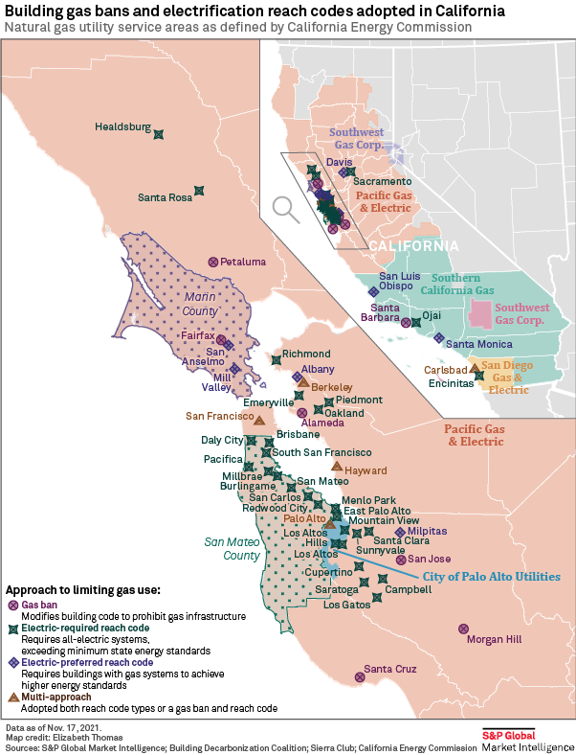
Image Source: https://www.spglobal.com/marketintelligence/en/news-insights/latest-news-headlines/gas-ban-monitor-calif-count-reaches-50-as-west-coast-movement-grows-67732585

Additionally, in Washington State, a measure has passed in the state’s Building Code Council to revise the state’s energy code to require new businesses and apartments to use heat pumps for space heating, and at least 50% of water heating. This new rule will come into effect on July 1, 2023.

However, while these efforts to restrict fossil fuels and natural gas for building heating are moving forward, they are actively being prohibited in other states that heavily use natural gas. As of 2022, twenty states, including Utah, Missouri, Florida, Texas, Ohio, Georgia, and Arizona have passed prohibitions preventing any restrictions or prohibitions on connections to natural gas utilities for building heating.

NYSERDA
NYSERDA
https://rpsc.energy.gov/energy-data-facts#:~:text=Of%20the%20energy%20used%20in,remaining%2045%25%20of%20total%20consumption.

