Building Science Education Solution Center – Cold Climate Heat Pump Sizing
Proficiency Level 3: Apply
Learning Objective 3.1:
- Apply energy efficiency improvements to lower cooling and heating loads to allow for a smaller heat pump.
- Apply the steps used to size a cold climate air source heat pump (ccASHP).
Lecture Notes 3.1:
The guidance in this module can be applied to both new construction and retrofit scenarios, though some guidance may not be relevant to new construction.
Before installing a heat pump system, first evaluate whether the home has energy efficiency opportunities which would allow a smaller, less expensive system to be installed. This evaluation can be conducted alongside the Manual J sizing effort. Upgrades to the building envelope and ductwork can significantly lower heating loads. Such upgrades include:
- Duct sealing: Losses through ductwork can add significant heating and cooling loads, both on the supply and return ductwork.
- Whole house air sealing: Excessive infiltration can significantly increase heating loads.
- Adding insulation: Some older homes have no wall insulation or limited floor and ceiling insulation.
- Window retrofits: Older windows can create significant infiltration or convective heating losses. Windows can be upgraded in several methods, including low-e storm windows, reglazing, and full replacement.
Once efficiency measures have been implemented, the sizing process can begin. Sizing a cold climate heat pump is similar to sizing a standard heat pump. The primary difference is that the designer is likely to target the size of the heat pump to meet the heating load rather than the cooling load. The following steps can be taken to size and select a cold climate heat pump:
Step 1: Understand Goals and Limitations
This step will require discussion with the homeowner to determine their goal for the main purpose of the heat pump. The general options are:
- The primary purpose of the heat pump is to provide cooling, but it will provide some heat in milder weather.
- The primary purpose of the heat pump is to provide cooling, but the homeowner would like to get as much heating out of the unit as reasonable.
- The primary purpose of the heat pump is to provide most of the heating required, but a backup heating system or significant auxiliary heat is available.
- The heat pump is intended to provide all the heat.
Deciding on a sizing approach mostly depends on which of these options seems to best suit the homeowner.
It is also important to determine the homeowner’s motivation for choosing a heat pump rather than a furnace, boiler, or other heating equipment. The motivation may have to do with concerns about climate change, rising fuel costs, indoor air quality, or improved comfort. For more information on homeowner goals and expectations, refer to Introduction to Heat Pumps. Homeowner motivations will help narrow down the system options.
Step 2: Choose a Sizing Approach
Sizing approach based on Step 4 of NRCan ASHP Sizing and Selection Guide
Based on the homeowner’s goals determined in Step 1, decide which of the following approaches to take when sizing and selecting equipment:
- The homeowner is primarily interested in the heat pump for air-conditioning. It may be used to provide some heat in mild weather but is not the primary heating system: Size to the design cooling load. A ccASHP is not necessary.

- The primary purpose of the heat pump is to provide cooling, but the homeowner would like to get as much heating out of the unit as reasonable: Select a variable capacity or multi-stage unit and size the unit such that the mid- or low end of its cooling capacity range will meet the design cooling load. The unit may technically be oversized for cooling, but the modulating or staged capacity will mitigate oversizing issues. This approach allows a larger unit with more heating capacity to be selected.

- The primary purpose of the heat pump is to provide heat, but a backup heating system or significant auxiliary heat is available, or the system is a dual fuel system. In this case the heat pump is designed to provide most, but not all of the heat. Select a ccASHP and size the heat pump such that it is somewhat undersized for heating. One approach to this undersizing is to size the heat pump to meet a certain percentage of the design heating load (for example 80%). Another approach is to target a specific balance point temperature which is warmer than the design heating temperature. Try to select a unit with a minimum cooling capacity which is lower than or equal to the design cooling load.

- The heat pump is intended to provide all or nearly all the heat. Size to meet the design heating load at the location’s design heating temperature. Incorporating a safety factor to slightly oversize the unit for heating is acceptable, especially if the goal is to minimize or eliminate the use of auxiliary heat. Use a ccASHP. Select a unit with a minimum cooling capacity which is lower than or equal to the design cooling load.

Table 1 summarizes these four sizing approaches.
 | Cold Climate Sizing Approach | Heating Capacity | Cooling Capacity | Heat Pump Type
1 | Size for cooling | Significantly undersized | Right-sized | Single-stage will work
2 | Size for cooling, but maximize available heating | Undersized | Oversized at max capacity, but right-sized within capacity range | Multi-stage or variable capacity, possibly ccASHP
3 | Size to meet most of the heating load | Somewhat undersized | Oversized at max capacity. Try to right-size within capacity range | ccASHP with wide enough turn-down ratio for proper cooling
4 | Size to meet all the heating load | Right-sized | Oversized at max capacity. Try to right-size within capacity range | ccASHP with wide enough turn-down ratio for proper cooling
Table 1: Cold climate sizing approaches
Options 1, 2, and 3 will result in a balance point temperature which is warmer than the design heating temperature, which means that an auxiliary source of heat will be needed for the colder parts of the winter.
The main goal in any sizing strategy is to provide the required heating or cooling load while minimizing short-cycling time. During cooling, short-cycling lowers efficiency and causes issues with humidity. During heating, short-cycling lowers efficiency significantly and can also cause comfort issues. To avoid this problem, it is important to use these principles in the context of the sizing approach. The simplest example is when sizing for the full heating load. The heat pump must meet the load at the design temperature to ensure that supplementary heating is not required. To reduce cycling, the low capacity at 47°F/8.3°C should be close to the heating load at that temperature. Consider Figure 1 (Courtesy of NEEP) which shows the heating capacity of a variable speed heat pump and the heating design load of a house.

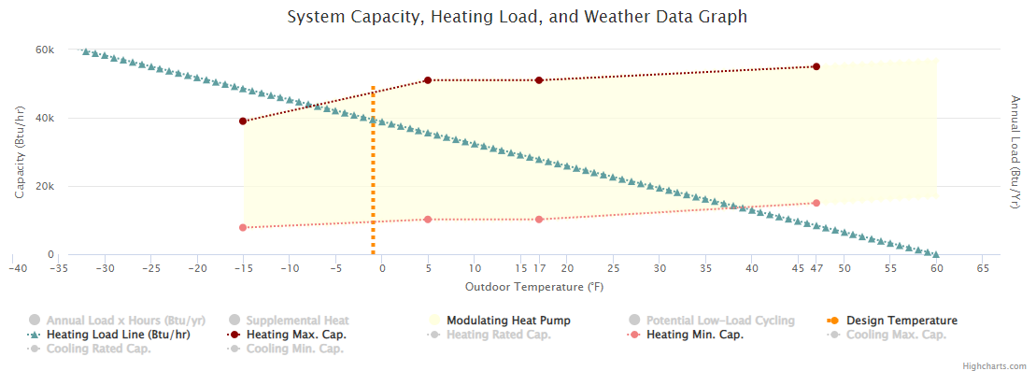
Figure 1: Heat pump heating capacity, load line, and design temperature (Courtesy of NEEP)
The green, straight line sloping downwards from left to right is the heating load line. This line indicates how much heat the house needs at different outdoor temperatures. For example, when it is 30°F/-1.1°C outside, the house will need about 20,000 Btu/hr of heat. When the temperature is 60°F/15.6°C or above, the house doesn’t need any heat from the HVAC system (solar gains and internal loads provide enough heat to maintain comfort). At the design temperature of -1.9°F/-18.8°C, the house needs 39,500 Btu/hr, which is the design load.
The dark red line at the top of the yellow area shows the maximum capacity of the heat pump at different outdoor air temperatures. The line tends to slope upward as the outdoor temperature gets higher – the heat pump’s capacity is higher when it is warmer outside. This is because it is easier for a heat pump to extract heat out of warm air than cold air. The red line at the bottom of the yellow area is the minimum capacity of the heat pump at different temperatures. At any given outdoor temperature, the heat pump can provide any amount of heat between its minimum capacity and its maximum capacity. This is because the heat pump is a modulating (variable speed) unit. The yellow area is the full range of heat pump capacity, called the modulating zone. Heat pumps are often most efficient when operating in this zone.
The vertical orange line shows the design outdoor temperature for the location of the house. This line depends only on the weather data for that location; it is not affected by the characteristics of the house or the characteristics of the heat pump.
The green heating load line only tells us about the house; it is not affected by the heat pump. The red lines and yellow area only tell us about how the heat pump performs; they are not affected by the characteristics of the house. By putting all these lines on the same chart, we can see how well the heat pump matches the needs of the house.
The circles indicate three important intersections: where the heating load line intersects with the minimum capacity line (black circle), where the heating load line intersects with the design temperature line (red circle), and where the maximum capacity line intersects with the design temperature line (blue circle). Comparing the two circles on the orange design temperature line lets us know whether the heat pump is oversized or undersized for heating. If the heating load of the house at the design temperature (red) is higher than the maximum heat pump capacity at the design temperature (blue), the heat pump is undersized. If it is the other way around, the heat pump is oversized. Ideally the blue and red circles would be as close together as possible, indicating that the unit is neither oversized nor undersized.
The black circle in the lower right helps us understand how much the unit will short-cycle at low heating loads. To the left of the circle, the heating load of the house is within the modulating zone, and the heat pump can meet the load continuously. To the right of the circle, the minimum capacity of the heat pump is higher than the heating load for the house, so the heat pump must cycle on and off to maintain comfort. This short-cycling zone is indicated by the gray area. Ideally this area would be as small as possible.
According to the chart, this heat pump is well sized to meet the whole heating load of the house. It has sufficient maximum capacity at the design temperature. It has a low minimum capacity at mild temperatures, which means that the time spent short cycling is low. When sizing, attempt to maximize the crossover between the modulating zone (yellow area) and the heating load line of the house.
Step 3: Choose a System Configuration
How to configure the system will depend on the characteristics of the home as well as the goals and motivations discussed with the homeowner in Step 1. The sizing approach in Step 2 can also inform the decision made here, though the two steps can be switched. There are three primary options for system configuration: centrally ducted, single-zone mini-split, and multi-split (a split system with multiple indoor units and one outdoor unit). Illustrations of these system types are provided in Figures 2 – 5.
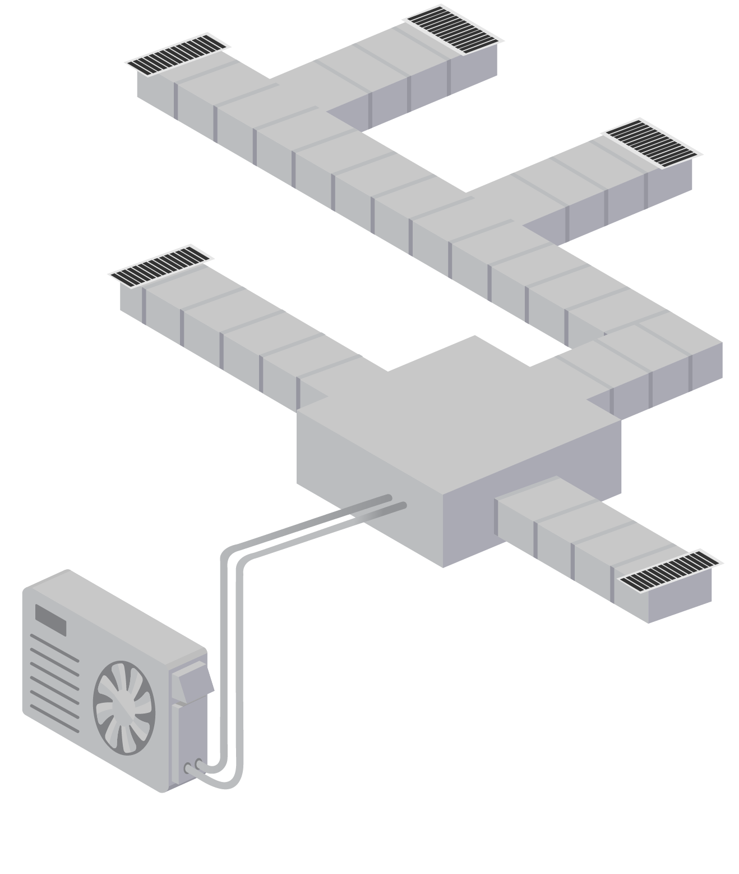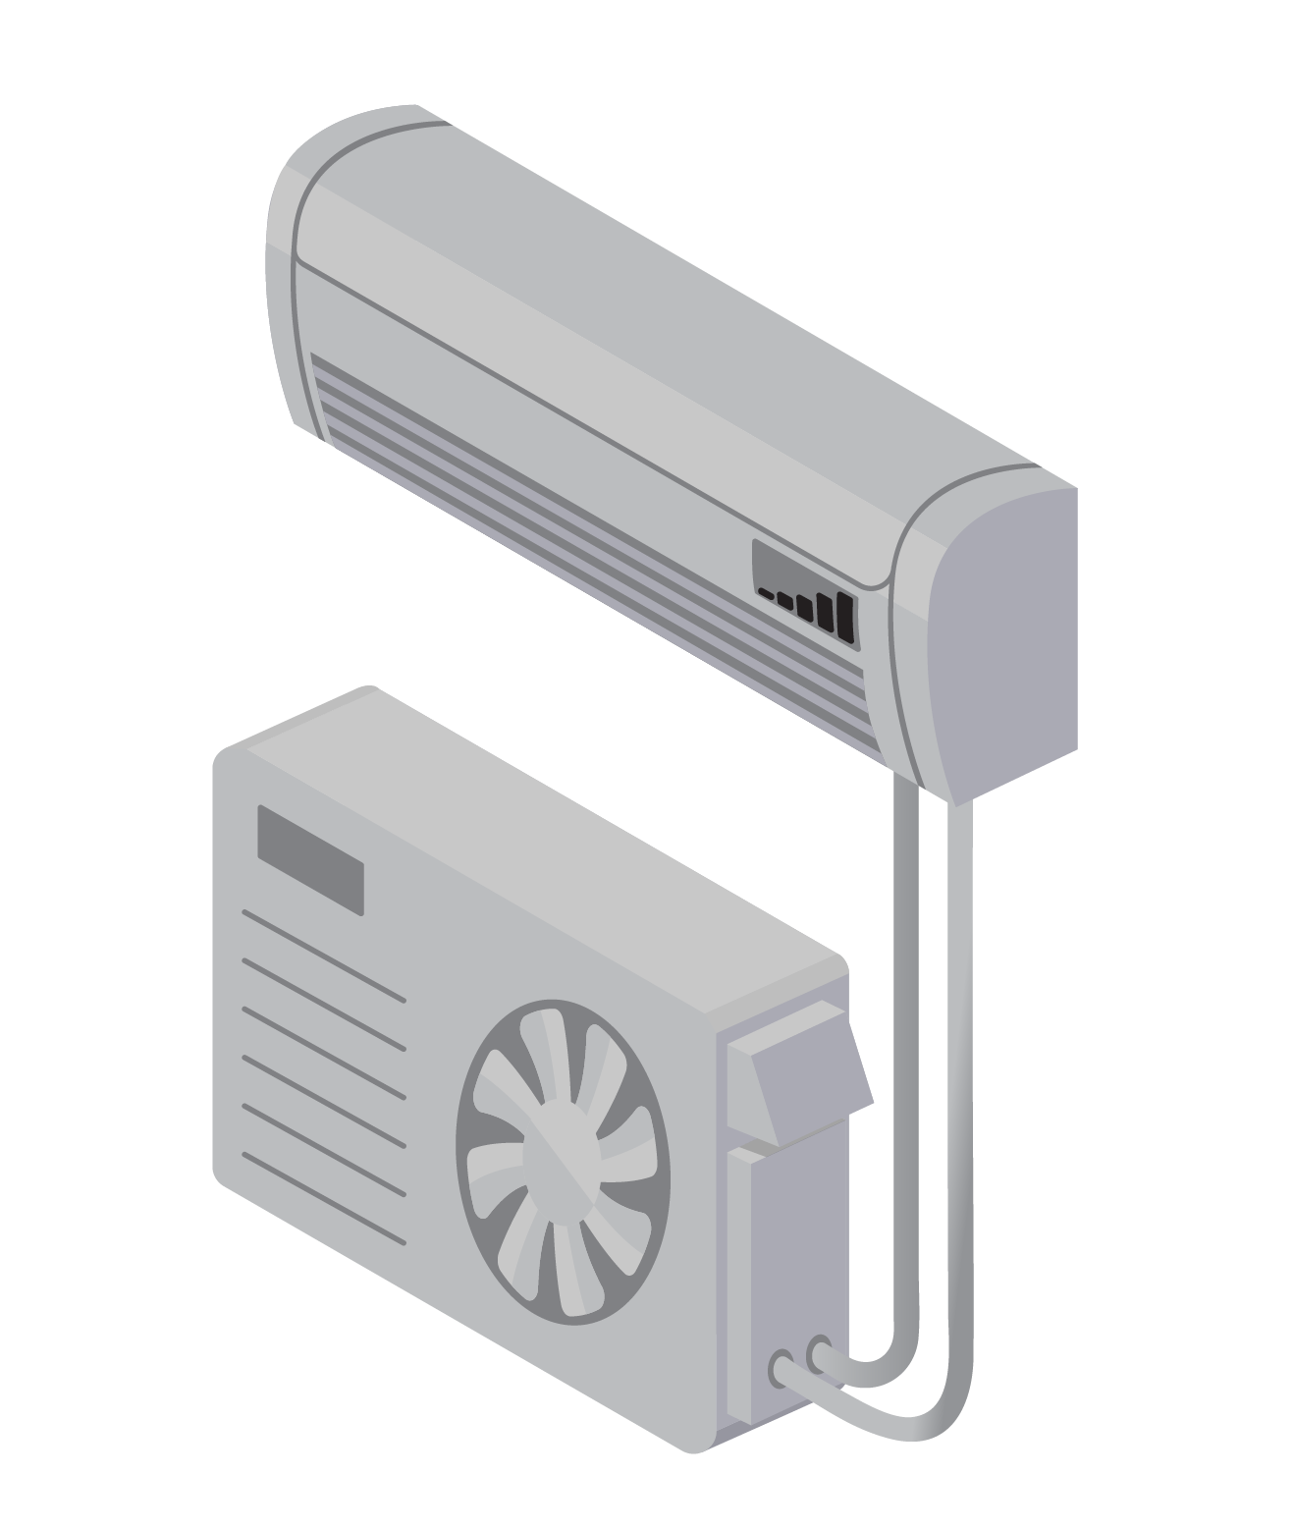
Figure 2: (Left) Centrally ducted heat pump configuration; Figure 3: (Right) Mini-split ductless heat pump configuration
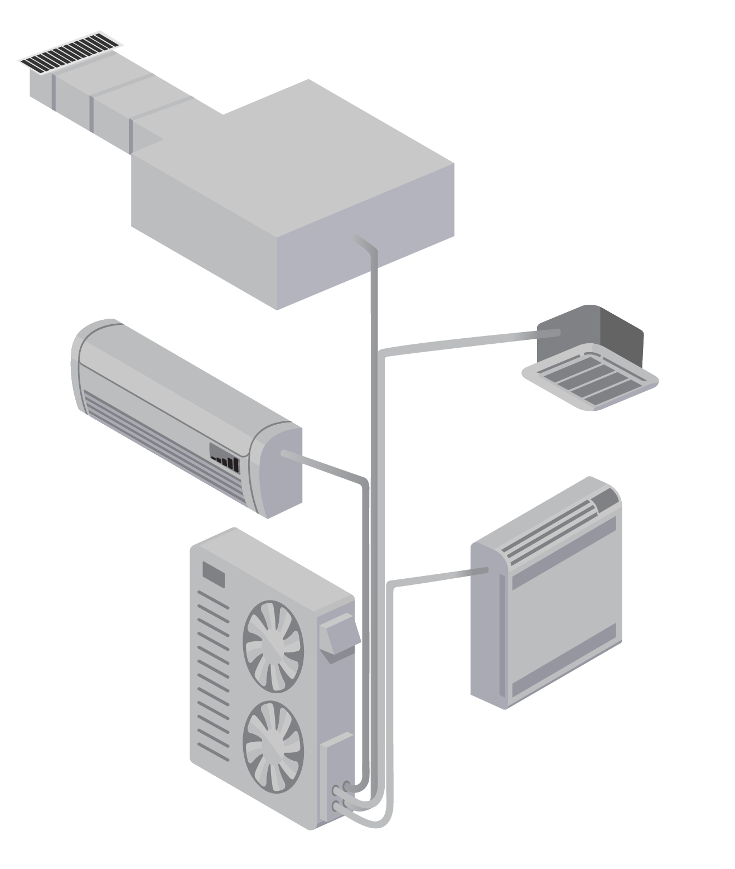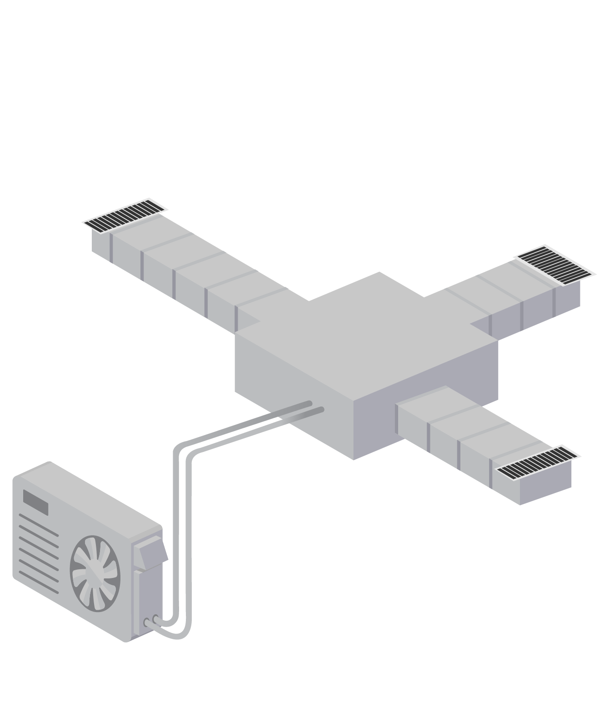
Figure 4: (Left) Multi-split system with one outdoor unit and multiple indoor units; Figure 5: (Right) Combination system with two ductless mini-splits and one compact-ducted system
Images courtesy of NYSERDA
As shown in Figures 3, 4, and 5, the mini-split and multi-split configurations can be ductless or compact-ducted systems. Systems can also be combined, with some indoor units being ductless and others ducted. Which configuration makes sense will depend upon whether the homeowner is looking for a whole-house solution or just wants to condition one area of the house. It will also depend on the space constraints within the home, as well as zoning needs.
If the new system is intended to provide all or most of the heating and cooling for the house, a centrally ducted system or a multi-split system will likely make the most sense.
- A centrally ducted system uses new or existing ducts to reach all areas of the home and can be relatively simple to install and maintain.
- A multi-split system serves the same purpose of conditioning the whole home but may be used if existing ductwork is insufficient or non-existent. Ductless units require somewhat more maintenance than ducted units.
If the new system is meant to only heat and cool one room or an isolated area of the house, mini-split systems are usually the best solution (ductless or compact-ducted).
- Mini-split ductless units can be placed in any room, and can be sized to meet varying loads, making them a good choice for an addition or a space that is not adequately conditioned by the main system of the house
- Compact-ducted mini-split systems can serve the same purpose as mini-split ductless units but can be placed in a plenum or existing duct. They are directly connected to the outdoor unit, and the air travels a short length through the duct to reach the space.
Some spaces may require a combination of the above options. A combination system could serve isolated spaces or provide conditioning for the whole home. The house may have a small duct system designed for a furnace, but not air conditioning. A central system could be installed to use the existing ducts, with mini-splits serving rooms that require extra cooling in the summer or extra heating in the winter.
If the heat pump is to be installed in an existing home, it is important to understand what type of system currently exists, and whether it will remain in use or be taken out of service. If the existing system is ducted and will be taken out of service, the duct size and condition should be assessed to determine whether the existing ducts can be reused. If the ducts can be reused, a centrally ducted system may make the most sense. If the ducts cannot be reused, a ductless system, compact ducted, or a centrally ducted system with new ductwork may make the most sense depending on cost and other site-specific factors.
If the existing system is not ducted (hydronic or baseboard heat), then there may not be room available for a centrally ducted system and a mini-split or multi-split solution may be best. Similarly, if an existing ducted system is to remain in use, then it may not be reasonable for the new heat pump system to share ductwork with the existing system, and a ductless system may be most appropriate.
The system can also be configured to use a combination of ducted and ductless equipment. This may be appropriate when an existing duct system requires a smaller central heat pump, and a mini-split meets the remaining demand. It can also be an effective strategy if certain rooms in the house get much colder or hotter than other parts of the home. It also allows for zone thermostat control.
Multi-splits are a valid approach for whole-house solutions without a centrally ducted system. This configuration uses one outdoor unit paired with multiple indoor heads, each with its own thermostat. This requires careful zonal sizing as well as whole-house load sizing. An alternative approach to this method is using more than one mini-split system. This requires more outdoor units but allows for some redundancy and potentially higher efficiency. Multiple systems may also be required for large houses with high loads in cold climates. Residential heat pumps top out at 5 tons (60,000 Btu/hr) nominal capacity, which will not meet the heating load of some homes. Dividing the home into two or more zones will break the heating load down into manageable portions, each of which can be handled by a separate heat pump system.
Step 4: Perform Heating and Cooling Load Calculations
Regardless of whether the focus of the system is on heating or on cooling, heating and cooling load calculations should both be performed to allow selection of equipment which can best serve both purposes. While numerous rules of thumb and simplified calculators exist, ACCA Manual J should be used to obtain reliable results. Accurate results require a detailed calculation of loads resulting from the building’s characteristics, including building orientation, insulation, windows, and air leakage, as well as local climate data. ACCA-approved software tools are available to simplify the process and generally cost $500-$1,000 per license.
If the new heat pump is intended to only serve a portion of the house, then the heating and cooling loads should be calculated to include only that portion of the house.
Step 5: Select Equipment
The results of the heating and cooling load calculations will be used to select the specific heat pump equipment. ACCA Manual S 2014 provides a sound method for selecting heat pump equipment, using the results from ACCA Manual J. However, Manual S 2014 focuses on methods appropriate for warm climates and does not fully address sizing heat pumps for very cold applications.
When selecting equipment to provide most or all of the home’s heating needs, the selection process will first focus on equipment that can meet the design heating load (or a certain percentage of the design heating load if the goal is only to meet part of the load). Any equipment which has appropriate heating capacity should then be reviewed to evaluate how it performs in cooling. If the minimum cooling capacity of the unit is above the design cooling load for the house, then the system will be oversized for cooling. In this case the designer should try to find a heat pump with a lower minimum cooling capacity at the design cooling temperature.
Obtaining accurate load calculation results becomes very important for proper equipment selection. Using rules of thumb will typically lead to the selection of a larger unit to meet an unrealistic heating load. This will make it more difficult for the designer to select a heat pump with a sufficiently low minimum cooling capacity for the actual cooling load.
Manufacturers’ extended performance tables should be used to determine heating and cooling capacities at the design temperatures for the home’s location. The capacity at colder design temperatures may not be listed by some manufacturers. For single or two-speed heat pumps, this data can be found on manufacturer websites. The Cold Climate Air Source Heat Pump (ccASHP) List by NEEP provides a single source for capacity tables and charts for multiple ccASHP manufacturers, though the information provided is not as comprehensive as the manufacturers’ tables. See Table 2 for an example. Variable capacity heat pumps have minimum and maximum outputs for each temperature. Maximum output is important to verify that the highest load of the house can be met. Minimum output will impact how frequently the heat pump is forced to “cycle,” or turn off and on, which impacts the efficiency.
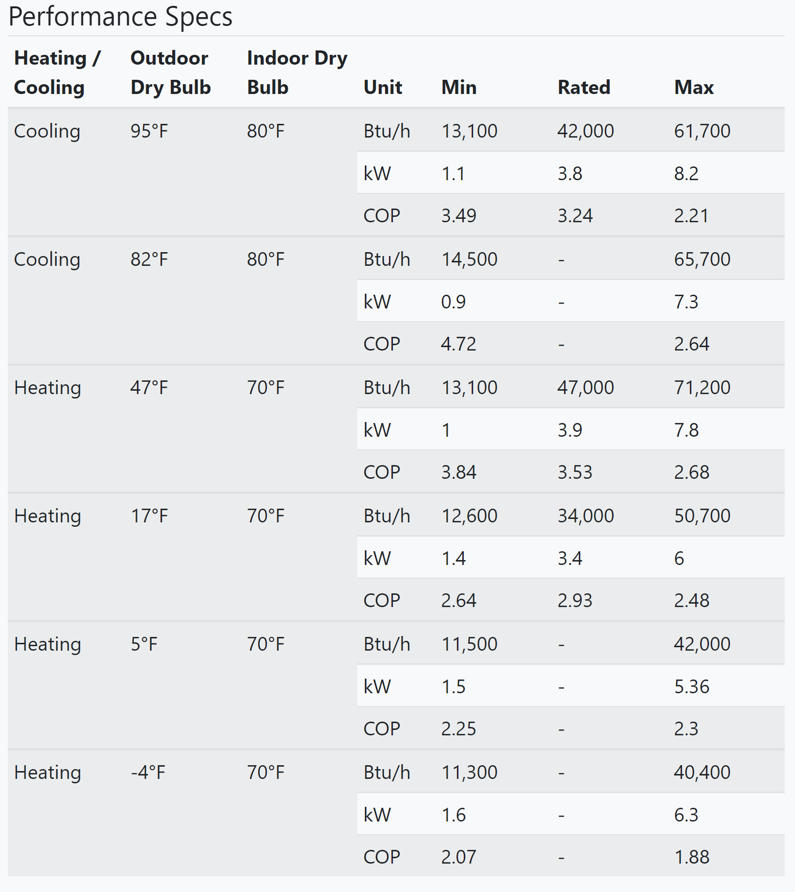
Table 2: Variable capacity heat pump performance data
When selecting equipment, it is important to pay attention to minimum capacities at non-design temperatures (warmer heating season temperatures, cooler cooling season temperatures). This will help ensure the final selection can perform well under low-load conditions.
If a unit’s capacity at a specific design temperature is not specified, linear interpolation can be used to estimate output at a given temperature. Using Table 1, the equipment capacity for design temperatures such as -1.9°F/-18.8°C can be found by interpolating between the listed capacities at 5°F/-15°C and -4°F/-20°C. For more information, see the lecture notes on Linear Interpolation.

Extended performance data includes heating and cooling outputs at more outdoor air temperatures than required by AHRI. This data is very useful for matching heating loads at low temperatures, especially design temperatures below 5°F/-15°C. It is also used to match cooling loads at design temperatures other than 95°F/35°C. Manufacturer literature such as specification sheets or proprietary equipment tools often contain this extended performance data in 5°F/2.7°C increments. See Table 3 for an example of performance data for a single-stage heat pump. T.C. and S.C. are total cooling and sensible cooling respectively, both given in BTU/hr. Latent cooling is the difference between these two values. The rated cooling condition for equipment is 95°F/35°C entering air, 80°F/26.7°C indoor dry bulb (ID DB), 67°F/19.4°C indoor wet bulb (ID WB). To use this data, it is also important to know how much airflow the system will operate with. In Table 1, this is labeled as indoor cubic feet per minute (IDCFM).

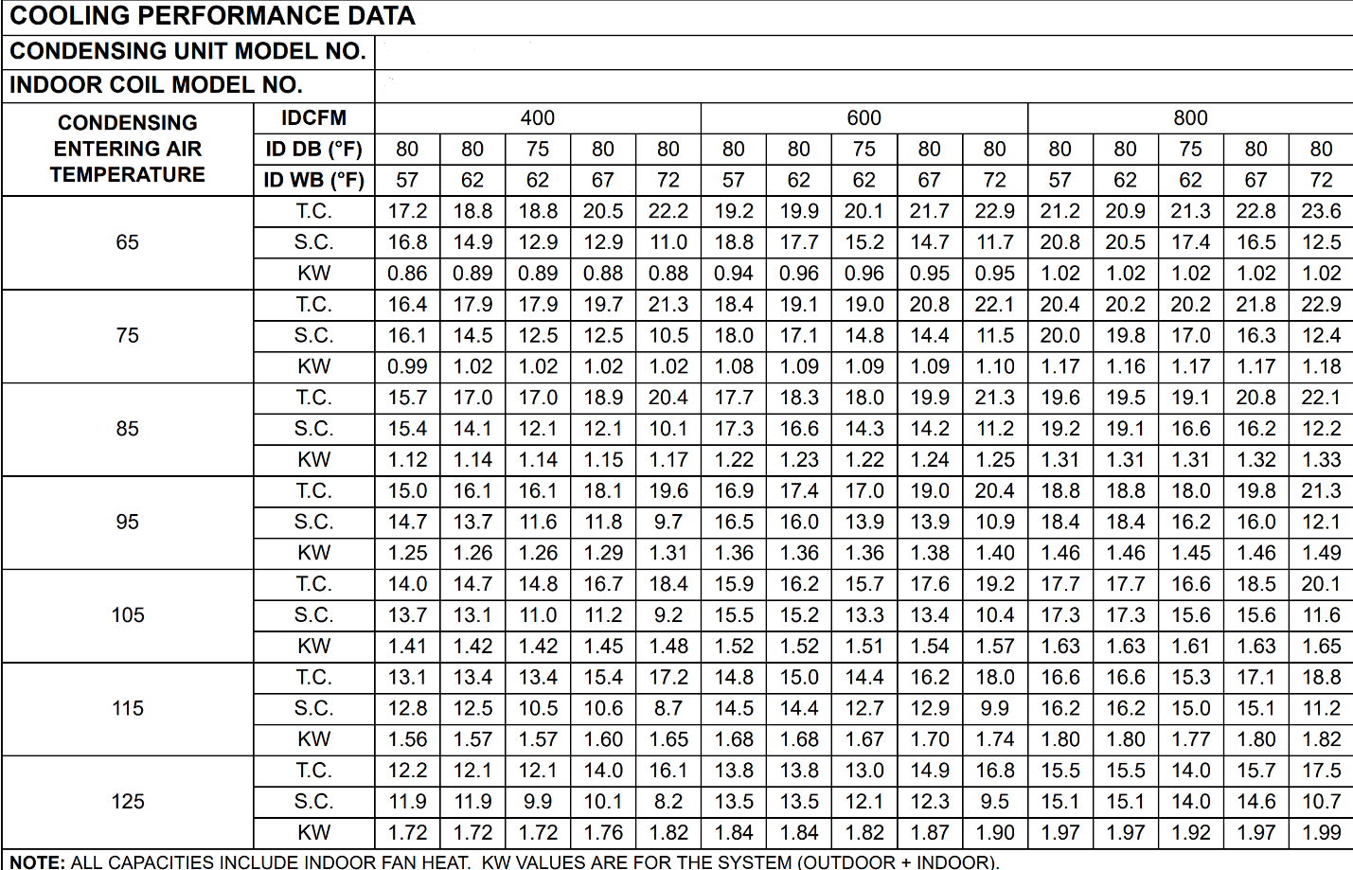
Table 3: Single-speed heat pump extended performance data
Latent cooling capacity is an important consideration for homes in humid climates or for tightly built homes where humidity is not properly exhausted. Significant interior humidity sources include showering, cooking, and respiration. Dehumidification has historically been an important function of traditional heat pumps and air conditioners, particularly in humid climates (ex. Climate zones in Moisture Regime “A”). Newer variable-capacity heat pumps sized to meet higher heating loads may not always provide adequate dehumidification, however. If installing a variable capacity cold-climate heat pump in a humid climate, or if high humidity may be an issue in the home, consider the following information:
- Variable-speed blowers are often required to pair with variable-capacity heat pumps to achieve better dehumidification. Lower airflow speeds lead to more dehumidification.
- Latent capacities are found in extended performance data from manufacturers (this data is not currently available on the NEEP database).
- Utilizing a separate whole-house dehumidifier may be the most reliable way to provide adequate dehumidification. Whole-house dehumidification allows for the latent capacity of a heat pump unit to be disregarded, meaning that equipment can be sized for large heating loads more easily.

Once the selection field has been narrowed down to units that provide the target capacities for both heating and cooling, a specific model should be selected based on additional criteria including efficiency and installed cost. Higher efficiencies and/or better cold-weather performance usually correlate to higher costs. Other factors, including whether the product qualifies for specifications from organizations like NEEP, ENERGY STAR, or the Consortium for Energy Efficiency (CEE), as well as local state or utility incentive programs for purchasing and installing cold climate heat pumps can also factor into equipment choice.
Problem Set 3.1:
- What approach to sizing a ccASHP should be taken if the heat pump will be the only source of heat for the house?
  - Size to meet most of the design heating load.
  - Size to meet the design cooling load.
  - Size to meet the design heating load.
  - Size for cooling but maximize available heating capacity.

- What approach to sizing a ccASHP should be taken if the homeowner wants to displace most, but not all, of the existing heating system’s output?
  - Size to meet most of the design heating load.
  - Size to meet the design cooling load.
  - Size to meet the design heating load.
  - Size for cooling but maximize available heating capacity.

- When selecting a heat pump to meet most or all of the design heating load, what should a designer look for in terms of the unit’s cooling capacity?
  - The unit’s maximum cooling capacity should be lower than the design cooling load.
  - The unit’s minimum cooling capacity should be higher than the design cooling load.
  - The unit’s minimum cooling capacity should be higher than the design heating load.
  - The unit’s minimum cooling capacity should be lower than the design cooling load.

- What is the proper procedure for determining heat pump outputs at a temperature not given in performance tables?
  - Perform a linear interpolation between two values greater and less than the desired temperature.
  - Choose the output from the closest known temperature.
  - Use data from a similar heat pump that specifies the desired temperature.
  - Make a best guess based on available information.
- What are the effects of short cycling?
  - Increased efficiency
  - Increased occupant comfort
  - Increased efficiency and occupant comfort
  - Decreased efficiency and occupant comfort

- Why is it important to consider the latent cooling capacity when selecting a heat pump?
  - Variable speed heat pumps sized for heating provide better dehumidification than traditional heat pumps.
  - Summertime humidity is not an issue in cold climates
  - Latent cooling capacity provides an indication of how well a unit dehumidifies in summer
  - Heat pumps and air conditioners are not relied upon for dehumidification

Learning Objective 3.2:
- Apply the sizing and selection process for a ccASHP
Lecture Notes 3.2:
The following examples illustrate the sizing and selection process for heat pumps in cold climates. The following four examples use the same house in the same climate location. The house has an existing ducted natural gas furnace and central air conditioning that needs to be replaced. The duct system has been evaluated and can accommodate a centrally ducted heat pump. In all examples, it was determined that a centrally ducted heat pump system would best suit the homeowners’ needs. However, in each example the homeowners have a different goal for their new heat pump system.
Because the physical characteristics of the house and its location are identical for each example, the results of the Manual J heating and cooling load calculations are also identical for each example.
The house has a conditioned floor area of 1,500 ft² and is located in Madison, WI in climate zone 5A. Manual J calculations were performed using the wall, roof, and floor insulation values, the window specifications, estimated infiltration, and other characteristics of the structure. The indoor design conditions are 70°F/21.1°C for heating and 74°F/23.3°C for cooling. The 1% and 99% outdoor design conditions for Madison, WI are 86.4°F/30.2°C (dry-bulb) and 72.4°F/22.4°C (Mean coincident wet-bulb) for cooling and -1.9°F/-18.8°C (DB) for heating. The ratio of heating degree days (HDD) at 65°F/18.3°C to cooling degree days (CDD) at 50°F/10°C is 2.67. The Manual J calculations showed a heating load of 39,500 BTU/hr and a total cooling load of 20,000 BTU/hr, comprised of a sensible cooling load of 16,400 BTU/hr and a latent cooling load of 3,600 BTU/hr. This results in a sensible heat ratio (SHR), which is calculated as total cooling load divided by sensible cooling load, of 0.82. Figure 6 shows the heating load line for this house. The house does not need any heat when the temperature outside is above 60°F/15.6°C, due to solar gains and internal heat gains.
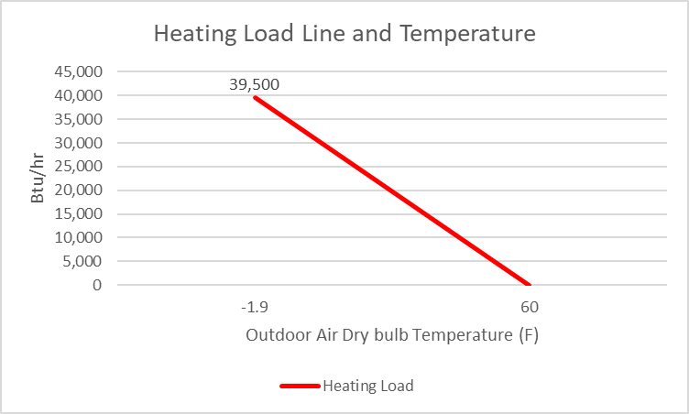
Figure 6: Heating load line as a function of outdoor air dry bulb temperature for a 1,500 ft² house in Madison, WI
ACCA Manual S 2014 outlines two scenarios for sizing heat pumps in the traditional manner. These guidelines are made for single-stage equipment. It allows for oversizing in drier, colder climates where dehumidification is less of an issue.
Sizing Condition | Minimum Cooling Capacity at Design Temperature | Maximum Cooling Capacity at Design Temperature
SHR > 0.95 OR HDD:CDD > 2.0 | 0.9 × total cooling load | total cooling load + 15,000 BTU/hr
SHR ≤ 0.95 OR HDD:CDD ≤ 2.0 | 0.9 × total cooling load | 1.15 × total cooling load
Table 4: ACCA Manual S 2014 Sizing Conditions
It should also be ensured that the latent capacity is sufficient for the home in each scenario. This information is found in extended performance data from manufacturers.
However, in many applications in cold climates, these limits do not allow for the full heating load to be met by a heat pump. Advances in cold climate heat pump technology have made it possible to meet heating loads and cooling loads without strictly following ACCA Manual S 2014 methods.
Example 1: Size for Cooling
Discussions with the homeowner indicate that both their furnace and air conditioner need to be replaced. They would like to continue to use a gas furnace for heating. However, they like the idea that they can replace their air conditioner with a heat pump and use the new heat pump system to displace some of their gas heating. They see this as only a side benefit and not a design goal, however. Their primary goal for the new heat pump is to provide adequate cooling. Based on this information, the HVAC contractor chooses to size and select the new equipment to target the design cooling load: The unit will be right sized for cooling to provide 20,000 Btu/hr at 86.4°F/30.2°C.
- The unit will likely be undersized for heating.
- A single-stage unit sized using traditional methods is most appropriate.
Per Manual S 2014 guidance, heat pumps with a cooling capacity in the range of 18,000 BTU/hr to 23,000 BTU/hr at design temperature should be used. The HVAC contractor searches manufacturer product information to find heat pumps with a cooling capacity at the design temperature in that range.
Initially the contractor may search based on the nominal capacity of the products. Once the field has been narrowed down, each unit is evaluated based on its actual performance data. The heat pumps should be assessed based on their cooling capacity at the outdoor cooling design temperature for this location (86.4°F/30.2°C) if possible, not simply the standard rated output at 95°F/35°C.
Two appropriate options are selected for the homeowner, as shown in Tables 1-1 and 1-2. The first table contains the nominal capacity in tons and the rated values for equipment in BTU/hr.
Table 1-1: Basic performance data
Unit | Compressor Type | Nominal Capacity (tons) | AHRI Rated Cooling Capacity at 95°F/35°C (Btu/hr) |  | AHRI Rated Heating Capacity (Btu/hr) |  | Lowest Temperature Measured and Capacity (Btu/hr)
 |  |  | High | Low | 47°F/8.3°C | 17°F/-8.3°C
1A | Single-stage | 1.5 | 18,000 | - | 16,400 | 9,400 | - | -
1B | Single-stage | 2 | 22,800 | - | 20,600 | 13,300 | - | -

From this starting point, the contractor consults extended performance data for the key criteria. The contractor needs to focus on the Cooling Capacity at 86.4°F/30.2°C. This information is not given directly in the extended performance data, but enough information is given to allow linear interpolation or a reasonable estimate. The results of the contractor’s calculations are shown in Table 1-2. Balance point temperature can be calculated by plotting the heating capacity of the unit against the heating load line of the house. The intersection is the balance point temperature.
Table 1-2: Example-specific performance data, calculated
Unit | Total Cooling Capacity at 86.4°F/30.2°C (Btu/hr) | Latent Cooling Capacity at 86.4°F/30.2°C (Btu/hr) | Balance Point Heating Temperature (°F/°C)
1A | 18,900 | 5,670 | 37.7/3.2
1B | 23,500 | 6,340 | 33.0/0.6

Each of the above options has its advantages. Unit 1A is within the Manual S 2014 sizing guidance and has the smallest nominal capacity, which means it likely costs less than similar units with more capacity. For the goal of sizing for cooling, this may be the most cost-effective option. Unit 1B is slightly above the Manual S 2014 guidance for single-speed heat pumps. It will adequately cool the home, but there may be slight humidity issues. Since it is a half-ton larger, it may cost more than Unit 1A. It will also displace more of the heating load than Unit 1A. Both options will need some form of supplementary heat, either electric resistance or a hybrid fossil-fuel system.
- Cooling provided is based on cooling capacity at 86.4°F/30.2°C
- Summer short-cycling and humidity control is based on minimum cooling capacity at 86.4°F/30.2°C (single-stage units have only one capacity) and latent capacity
- Heating displaced is based on the balance point heating temperature
Table 1-3: Key metric comparison
Unit | Cooling Provided | Summer Short-Cycling and Humidity Control | Heating Displaced
1A | Slightly undersized | Good | Poor
1B | Ample | Fair | Fair

Example 2: Size for Cooling but Maximize Heating
Discussions with the homeowner indicate that both their furnace and air conditioner need to be replaced. They like the idea that they can replace their air conditioner with a heat pump and use the new heat pump system to displace some of their gas heating. Their primary goal for the new heat pump is to provide adequate cooling, but they would like to use the new heat pump system to displace as much heating as possible. They have some hesitation about fully relying on a heat pump for their heating, however, and would like to have a gas furnace as their primary heating. Based on this information, the HVAC contractor chooses to size and select the new heat pump to target the design cooling load while maximizing the heating output of the equipment. Manual S 2014 guidelines should be disregarded for this case since they have limited applicability to variable-capacity units. The criteria used to size the heat pump are:
- The minimum cooling output at 86.4°F/30.2°C must be less than 20,000 Btu/hr.
- The maximum cooling output at 86.4°F/30.2°C can be greater than 20,000 Btu/hr.
- Target a high maximum heating capacity at 47°F/8.3°C and 17°F/-8.3°C.
- Units with lower minimum heating capacities at 47°F/8.3°C will be preferred (to minimize cycling).
- A multi-stage or variable capacity unit will be most appropriate, single stage units will not fit the application as well.
Initially the contractor may search based on the nominal capacity of the products. For a cooling load of 20,000 Btu/hr, units with a nominal capacity of 1.5 to 2.5 tons is a good starting place. Once the field has been narrowed down, each unit is evaluated based on its actual performance data. The heat pumps should be assessed based on their cooling capacity at the outdoor cooling design temperature for this location (86.4°F/30.2°C), not simply the standard rated output at 95°F.
Three appropriate options selected for the homeowner, as shown in Table 2-2. The first table contains the nominal and rated values for equipment in BTU/hr. From this starting point, consult extended performance data for the key criteria. For this example, focus on the total and latent cooling at 86.4°F/30.2°C and the balance point temperature, in the second table.

Table 2-1: Basic performance data
Unit | Compressor Type | Nominal Capacity (tons) | AHRI Rated Cooling Capacity at 95°F/35°C (Btu/hr) |  | AHRI Rated Heating Capacity (Btu/hr) |  | Lowest Temperature Measured (°F/°C) and Capacity (Btu/hr)
 |  |  | High | Low | 47°F/  8.3°C | 17°F/  -8.3°C
2A | Variable-capacity | 2 | 23,000 | 8,300 | 23,000 | 15,600 | -22/-30 | 15,800
2B | Variable-capacity | 2.5 | 34,000 | 8,500 | 32,000 | 32,000 | -4/-20 | 27,200
2C | Variable-capacity | 2.5 | 31,400 | 11,000 | 28,600 | 19,400 | -22/-30 | 19,600

Table 2-2: Example-specific performance data, calculated
Unit | Total Cooling Capacity at 86.4°F/30.2°C (Btu/hr) | Latent Cooling Capacity at 86.4°F/30.2°C (Btu/hr) | Minimum Heating Capacity at 47°F/  8.3°C (Btu/hr) | Balance Point Heating Temperature (°F/°C)
2A | 9,425 – 23,529 | 4,700 | 8,500 | 31.0/-0.6
2B | 8,963 – 35,985 | 10,800 | 7,200 | 13.0/-10.6
2C | 11,662 – 32,128 | 8,000 | 13,500 | 21.1/-6.1

Each of the above options has its advantages. All three are variable-speed, meaning they benefit from the ability to modulate capacity. The tables above show how the nominal capacity does not tell the whole story for variable-speed equipment. Unit 2A is well-sized for cooling, since it meets the latent and total design load, and can modulate down well below the peak load. Units 2B and 2C are also suitable for cooling and could in fact meet much higher cooling loads if needed. For heating, Units 2B and 2C outperform Unit 2A overall. Unit 2B holds its capacity well in cold temperatures and has the lowest balance point, as well as the lowest minimum capacity at 47°F/8.3°C. Unit 2C has the next best balance point, though it’s minimum capacity at mild temperatures is higher. This will decrease efficiency in shoulder seasons. Unit 2A has the highest balance point, but its low minimum capacity makes it a good choice for heating during mild temperatures. All three options will need some form of supplementary heat, either electric resistance or a hybrid fossil-fuel system.
Table 2-3 provides a summary comparison of the units. Each column is based on the data in the tables above:
- Cooling Provided is based on the maximum cooling capacity at 86.4°F/30.2°C.
- Summer Short-Cycling and Humidity Control is based on the minimum total cooling capacity and latent cooling capacity at 86.4°F/30.2°C.
- Heating Displaced is based on the balance point temperature.
- Wintertime Short-Cycling is based on minimum heating capacity at 47°F/8.3°C

Table 2-3: Key metric comparison
Unit | Cooling Provided | Summer Short-Cycling and Humidity Control | Heating Displaced | Wintertime Short-Cycling
2A | Ample | Good | Fair | Good
2B | Ample | Great | Great | Great
2C | Ample | Good | Good | Fair

See Figure 7 for a visualization of the heating capacity of Unit 2C as it relates to the heating load of the home. Try to find the relevant points of interest: balance point temperature and the temperature below which the unit will cycle during heating. The first is at the intersection of the green heating load line and dark red maximum heating capacity line. The second is at the intersection of the green heating load line and light red minimum heating capacity line.
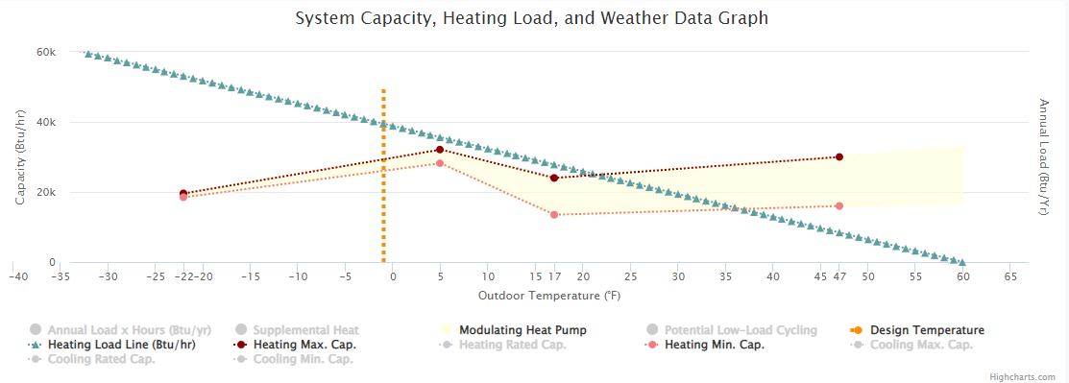
Figure 7: Heat pump 2C heating capacity, load line, and design temperature (Courtesy of NEEP)
Example 3: Size to meet most of heating load
Discussions with the homeowner indicate that they are not happy with their current natural gas furnace and would like to replace it along with their air conditioner. Their primary goal is to meet most of their heating load with a heat pump. They will use air conditioning in the summer, but it is not a priority. In this case, there are more variables to consider when sizing a system. An important one is cost-benefit. Sizing a heat pump to meet the whole load of a home might result in a heat pump that is out of the budget, and the slight boost in savings may not offset this cost. Based on this information, the HVAC contractor may choose to initially size to target the design heating load, then select equipment one size smaller. It is important to balance the goal of the project with the customer’s reason for choosing a heat pump. A priority on cost, energy consumption, or emissions may change which system is selected. This is an application where using the Manual S 2014 Sizing Guidance does not result in a good fit for the goal of the project, so those limits should not be followed. The contractor uses the following parameters when selecting equipment:
- The minimum cooling output at 86.4°F/30.2°C should be less than 20,000 Btu/hr.
- The latent cooling output at the rated speed at 86.4°F/30.2°C should be greater than 3,600 Btu/hr.
- The maximum cooling output at 86.4°F/30.2°C can be oversized (can be above 20,000 Btu/hr).
- The maximum heating capacity at –1.9°F/-18.8°C will be as close to 39,500 Btu/hr as is reasonable within cost limitations.
- Lower minimum heating capacities at 47°F/8.3°C will be preferred (to minimize cycling).
- A variable capacity ccASHP unit is required.
Initially the contractor may search based on the nominal capacity of the products. Once the field has been narrowed down, each unit is evaluated based on its actual performance data. The heat pumps should be assessed based on their heating capacity at a temperature slightly higher than the 99% outdoor heating design temperature for this location, not just the standard rated output at 47°F/8.3°C. This can be accomplished by looking at the balance point temperature. Balance point is a calculated value based on load and heating capacity and is the temperature below which supplemental heating is required.
For this sizing approach, there are several other factors that should be considered to ensure the customer’s goal is met, whether that is saving money or reducing emissions. The low heating capacity at higher temperatures, such as 47°F/8.3°C, should be low enough to maximize the heating hours spent in the modulation zone. The cooling design load should also be between the high and low cooling capacity. When deciding between systems, it may also be appropriate to compare HSPF/HSPF2 for each unit. Not all units have HSPF2 ratings available, so HSPF values are provided here.
Three appropriate variable capacity options are selected for the homeowner, as shown in Table 3-1 and Table 3-2.
Table 3-1: Basic performance data
Unit | Compressor Type | Nominal Capacity (tons) | Cooling Capacity at 95°F/35°C (Btu/hr) |  | AHRI Rated Heating Capacity (Btu/hr) |  | Lowest Temperature Measured (°F/°C) and Capacity (Btu/hr)
 |  |  | High | Low | 47°F/8.3°C | 17°F/-8.3°C
3A | Variable-capacity | 3 | 37,000 | 10,500 | 40,000 | 38,800 | -4/-20 | 30,000
3B | Variable-capacity | 3 | 37,000 | 11,000 | 38,000 | 36,000 | 5/-15 | 30,000
3C | Variable-capacity | 2.5 | 27,000 | 13,400 | 32,000 | 32,000 | 5/-15 | 32,000

Table 3-2: Example-specific performance data, calculated
Unit | Compressor Type | Balance Point Temperature (°F/°C) | HSPF and Minimum Heating Capacity at 47°F/8.3°C (Btu/hr) | Maximum Cooling Capacity  at 86.4°F/30.2°C (Btu/hr) | Minimum Cooling Capacity  at 86.4°F/30.2°C (Btu/hr)
3A | Variable-capacity | 5°F | HSPF 10.2  10,000 | 39,249 | 10,595
3B | Variable-capacity | 9°F | HSPF 10  10,000 | 37,000 | 11,662
3C | Variable-capacity | 10°F | HSPF 9  13,000 | 28,852 | 14,525
Each of the above options has its advantages and all will meet the primary goal of the homeowner. All units can provide ample cooling while meeting the requirement to have a minimum cooling capacity lower than 20,000 Btu/hr. Unit 3A has the lowest balance point temperature, which means it can displace the most heating load. It also has a low minimum heating capacity at 47°F, which will reduce short-cycling. Unit 3B displaces somewhat less of the heating load and is tied with Unit 3A for the lowest minimum heating capacity at 47°F/8.3°C. Unit 3C displaces the least amount of heat but is ½ ton smaller. This option has the highest minimum heating capacity at 47°F/8.3°C and will short-cycle the most. One important note is that it is unclear how well the units will dehumidify based on this information alone. They have enough latent capacity at the cooling design temperature but may face issues in lower load conditions. A separate dehumidification system may be needed.
Table 3-3 provides a summary comparison of the units. Each column is based on the data in the tables above:
- Cooling Provided is based on the maximum cooling capacity at 86.4°F/30.2°C.
- Summer Short-Cycling is based on the minimum cooling capacity at 86.4°F/30.2°C.
- Heating Displaced is based on the balance point temperature.
- Wintertime Short-Cycling is based on minimum heating capacity at 47°F/8.3°C.
Table 3-3: Key metric comparison
Unit | Cooling Provided | Summer Short-Cycling | Heating Displaced | Wintertime Short-Cycling
3A | Ample | Good | Best | Best
3B | Ample | Best | Good | Best
3C | Ample | Good | Good | Good

Figure 8 shows a visualization of the heating capacity for Unit 3B. Since all the options have a balance point higher than the design temperature, some form of supplementary heat will be required. Try to find the relevant points of interest: design heating load, balance point temperature, and the temperature below which the unit will cycle during heating. The first is at the intersection of the green heating load line and dotted orange design temperature line. The second is at the intersection of the green heating load line and the dark red maximum heating capacity line. The third is at the intersection of the green heating load line and light red minimum heating capacity line.
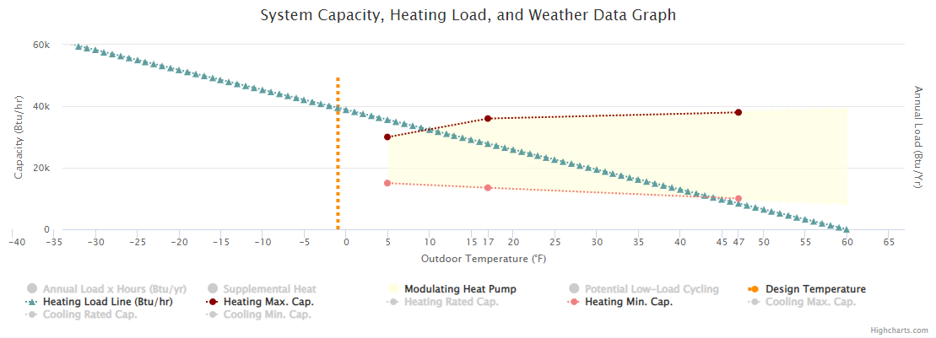
Figure 8: Heat pump 3B heating capacity, load line, and design temperature (Courtesy of NEEP)
Example 4: Size to meet all the heating load
Discussions with the homeowner indicate that they are not happy with their current natural gas furnace and would like to completely replace it along with their air conditioner. Their primary goal is to use a heat pump for all their heating needs. They will use air conditioning in the summer, but it is not a priority. Based on this information, the HVAC contractor chooses to size and select the new equipment to target the design heating load. Manual S 2014 guidelines do not allow for the full heating load to be met, so they should not be followed in this case. The contractor uses the following parameters when selecting equipment:
- The minimum cooling output at 86.4°F/30.2°C should be less than 20,000 Btu/hr
- The maximum cooling output at 86.4°F/30.2°C can be oversized (can be above 20,000 Btu/hr).
- The maximum heating capacity at –1.9°F/-18.8°C will be right-sized as close to 39,500 Btu/hr as possible.
- Units with lower minimum heating capacities at 47°F/8.3°C will be preferred (to minimize cycling).
- A variable capacity ccASHP unit is required.
Initially the contractor may search based on the nominal capacity of the products. Once the field has been narrowed down, each unit is evaluated based on its actual performance data. The heat pumps should be assessed based on their heating capacity at the outdoor heating design temperature for this location (-1.9°F), not just the standard rated output at 47°F/8.3°C. When sizing for the full heating load at very low design temperatures, it may be necessary to combine multiple options to meet the load. This can be done through strategically placed ductless units, a supplemental heating system, or an additional central heat pump if the duct capacity allows.
Three appropriate variable capacity options are selected for the homeowner, as shown in Table 4-1. For this example, focus on Measured Heating Capacity at design temperature, -1.9°F/-18.8°C.

Table 4-1: Basic performance data
Unit | Compressor Type | Nominal Capacity (tons) | Cooling Capacity at 95°F/35°C (Btu/hr) |  | AHRI Rated Heating Capacity (Btu/hr) |  | Lowest Temperature Measured (°F/°C) and Capacity (Btu/hr)
 |  |  | High | Low | 47°F/  8.3°C | 17°F/  -8.3°C
4A | Variable-capacity | 4 | 50,000 | 13,000 | 55,000 | 51,000 | -15/-26.1 | 39,000
4B | Variable-capacity | 3.5 | 46,000 | 12,000 | 47,000 | 42,200 | -15/-26.1 | 39,000
4C | Variable-capacity | 5 | 55,000 | 18,000 | 56,000 | 49,000 | -22/-30 | 27,000

Table 4-2 contains calculated values relevant to this example scenario. Most can be calculated using interpolation from manufacturer extended data, however “Percent Annual Load Modulating” is a more advanced calculation done by NEEP in their database.
Table 4-2: Example-specific performance data, calculated
Unit | Compressor Type | Measured Heating Capacity at -1.9°F/-18.8°C (Btu/hr) | Percent Annual Load Modulating | HSPF and Minimum Heating Capacity at 47°F/8.3°C (Btu/hr) | Minimum Cooling Capacity at 86.4°F/30.2°C (Btu/hr)
4A | Variable-capacity | 46,860 | 74.2% | HSPF 10.2  15,000 | 14,389
4B | Variable-capacity | 40,769 | 75.5% | HSPF 9.6  10,500 | 12,662
4C | Variable-capacity | 39,656 | 57.9% | HSPF 10  16,000 | 18,662

All the above options will meet the design heating load. They should also provide sufficient cooling since the low cooling capacity is lower than the cooling load. However, each has some advantages. Unit 4A easily meets the design load and operates within the modulation zone for a significant portion of its operation. It also has a high HSPF, indicating its efficiency. Unit 4B also meets the design heating load and operates within the modulation zone for a similar portion of its operation. It has a lower HSPF but is also ½ ton smaller than Unit 4A which may reduce the first cost. Unit 4C is the largest unit of the three, meets the design load, and has an HSPF in between the other two options. It spends less time modulating but would still meet the design goal of this project. One important note is that it is unclear how well these units will dehumidify based on this information alone. They have enough latent capacity at design temperature but may face issues in lower load conditions. A separate dehumidification system may be needed.
Table 4-3 provides a summary comparison of the units. Each column is based on the data in the tables above:
- Cooling Provided is based on the maximum cooling capacity at 86.4°F/30.2°C.
- Summer Short-Cycling is based on the minimum cooling capacity at 86.4°F/30.2°C.
- Heating Efficiency is based percent annual load modulating
- Wintertime Short-Cycling is based on minimum heating capacity at 47°F/8.3°C.
Table 4-3: Key metric comparison
Unit | Cooling Provided | Summer Short-Cycling | Heating Efficiency | Wintertime Short-Cycling
4A | Ample | Good | Near Best | Near Best
4B | Ample | Best | Best | Best
4C | Ample | Fair | Good | Good

Figure 9 is a visualization of Unit 4A and its capacity as it relates to the heating load of the house. Since all three options meet the design load at the design temperature, it is not necessary to install any forms of supplemental heat. Try to find the relevant points of interest: balance point temperature and the temperature below which the unit will cycle during heating. The first is at the intersection of the heating load line and maximum heating capacity line. The second is at the intersection of the heating load line and minimum heating capacity line.
Figure 9: Heat pump 4A heating capacity, load line, and design temperature (Courtesy of NEEP)
Problem Set 3.2:
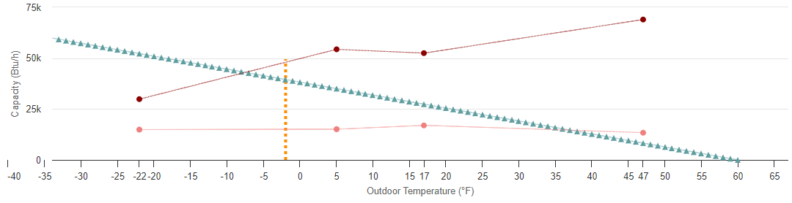
C
D
F
G
A
B
E
Figure 10: Heat pump heating capacity, load line, and design temperature for Problem Set 3.2 (Courtesy of NEEP)
- Reference Figure 10, an example heat pump and design load graph for a variable capacity heat pump on the NEEP database. Match the following terms with the appropriate location on the graph.
1) ____ Design temperature
2) ____ Heat pump minimum capacity line
3) ____ Heat pump maximum capacity line
4) ____ House heating load line
5) ____ Balance point temperature
6) ____ Design heating load
7) ____ Temperature where low-load cycling begins

- How can the balance point temperature be determined using a heating load and capacity chart?
  - By finding the intersection of the home’s heating load line and the system’s maximum heating capacity line
  - By finding the intersection of the home’s heating load line and the system’s minimum heating capacity line
  - By finding the intersection of the home’s heating load line and the design temperature line
  - By finding the intersection of the system’s maximum heating capacity line and the design temperature line

- Which of the following is NOT a key metric of a heat pump when sizing for heating?
  - Minimum heating capacity at design heating temperature
  - Maximum heating capacity at design heating temperature
  - Minimum heating capacity at 47°F
  - HSPF/HSPF2

- How should the cooling load be used when sizing for heating?
  - Disregard the cooling load
  - The cooling load should be greater than the minimum cooling capacity and less than the maximum capacity
  - The cooling load should be greater than the maximum cooling capacity
  - The cooling load should be less than the minimum cooling capacity

