Building Science Education Solution Center – Cold Climate Heat Pump Sizing
Proficiency Level 1: Remember
Learning Objective 1.1:
- Remember the principles of heat pump operation, and why some heat pumps need to be made specifically suitable for cold climates
Lecture Notes 1.1:
Basic heat pump components and operation are covered in the Introduction to Heat Pumps module.
Heat pumps work by transferring heat from one space to another. They can cool a building by moving heat from the inside to the outside or heat a building by moving heat from the outside to the inside. However, the colder it is outside, the more difficult it is for the heat pump to extract heat from the outside air. During especially cold temperatures heat pumps cannot extract adequate heat from the outdoors to keep the inside space warm. This is a difficult problem in colder climates and has historically prevented heat pumps from being widely accepted in these regions (climate zones 4 and higher as defined by the International Energy Conservation Code (IECC) Section R301).
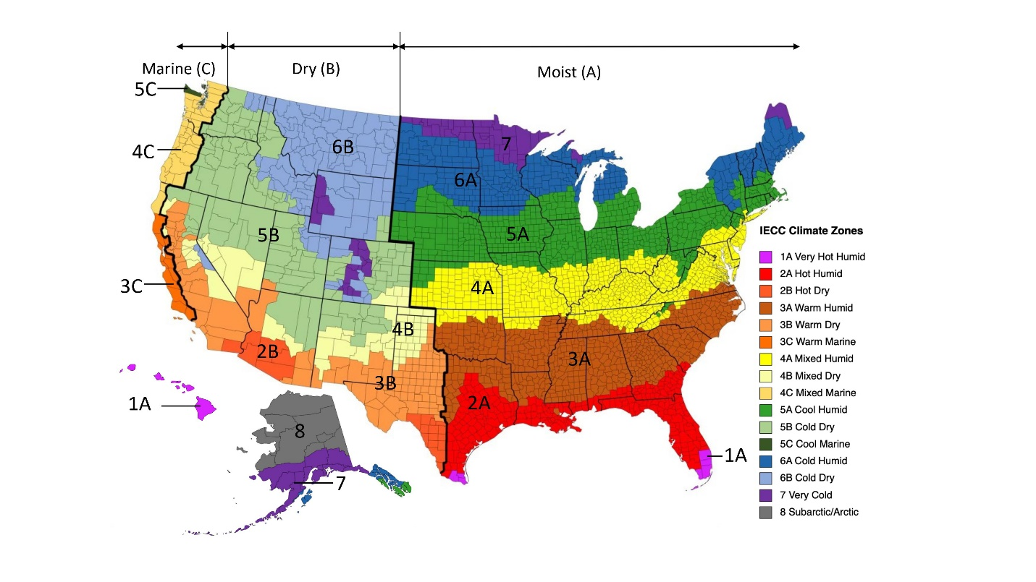
Figure 1: 2021 IECC Climate Zone map
Instead, up until recently, fossil-based heating systems have been preferred because they do not lose heating capacity when the outside temperature drops. An example of cold climate heat pump performance is shown in Table 1. According to Northeast Energy Efficiency Partnerships (NEEP) product list, it has a maximum heating capacity of 50,000 Btu/hr at 5°F, which is slightly above its nominal capacity.
Unit | Compressor Type | Nominal Capacity | Cooling Capacity (95°F) |  | AHRI Rated Heating Capacity |  | Measured Heating Capacity
 |  |  | High | Low | 47°F | 17°F | 5°F | -15°F
Unit A | Variable-capacity | 4 tons | 55,000 Btu/hr | 18,400 Btu/hr | 63,000 Btu/hr | 54,600 Btu/Hr | 50,000  Btu/hr | -
Table 1: Cold climate heat pump product data from NEEP database
Heat pumps have typically been installed with a backup heat source (auxiliary heat), usually an electric resistance coil. This electric resistance backup is inefficient and typically expensive form of heat, which should be minimized in all cases of heat pump installations. Cold climate heat pumps are designed specifically to maintain the use of the heat pump technology even at cold temperatures. It is important for HVAC technicians to understand the difference in the specifications of typical heat pumps compared to cold climate heat pumps.
Problem Set 1.1:
- Which regions in the United States are those considered to be “cold climate” regions?
Learning Objective 1.2:
- Remember the qualifications for cold climate heat pump as described by NEEP’s Cold Climate Air-Source Heat Pump Specification
Lecture Notes 1.2:
According to NEEP’s Cold Climate Air-Source Heat Pump Specification 4.0 (effective January 1, 2023), the following performance criteria must be met for an air source heat pump to be considered suitable for cold climate use:
- Heating Seasonal Performance Factor 2 (HSPF2): Greater than or equal to 8.5 for ductless systems, greater than or equal to 7.7 for ducted systems.
- Coefficient of Performance (COP) @5°F > 1.75 (when operating at maximum capacity)
- Seasonal Energy Efficiency Ratio 2 (SEER2) > 14.3
The specification applies to federally designated single-zone or multi-zone ducted or ductless air source heat pumps, as well as centrally ducted air source heat pumps. The heat pumps must have a variable capacity compressor with at least three different operating speeds and have been tested under the Air Conditioning, Heating, and Refrigeration Institute’s (AHRI)’s standard 210/240 Performance Rating of Unitary Air-conditioning & Air-source Heat Pump Equipment.

Problem Set 1.2:
- What are the minimum HSPF2, SEER2, and COP @ 5 °F needed to qualify an air-source heat pump as a cold climate heat pump, according to NEEP’s cold climate air-source heat pump specification?
Learning Objective 1.3:
- Remember key terms for cold climate heat pumps.
Lecture Notes 1.3:
Definition References:
- Energy.gov – Air-Source Heat Pumps (Energy Saver). Link: https://www.energy.gov/energysaver/air-source-heat-pumps
- NEEP Cold Climate Air-Source Heat Pump Specification (Version 4.0). Link: https://neep.org/sites/default/files/media-files/cold_climate_air_source_heat_pump_specification_-_version_4.0_final.pdf
- NYSERDA Technical Sizing and Design Training Presentation Content. Link: https://www.nyserda.ny.gov/All-Programs/Clean-Energy-Workforce-Development/Clean-Energy-Training-Resources
Coefficient of Performance (COP): A measure of how efficiently a heat pump can operate. It is calculated by dividing the energy produced (as heat) by the energy put into the system (as electricity).
Cold Climate Heat Pump: A heat pump that is designed to provide efficient heating in cold climates.
Design Heating Capacity: The output of a heat pump at the equipment’s winter design temperature (in Btu/hr).
Design Heating Load: The heating need that a heat pump must match at the target minimum winter temperature (in Btu/hr).
Ducted Heat Pump: A heat pump HVAC system that uses a building’s ductwork to deliver heating and cooling.
Ductless Heat Pump: A heat pump HVAC system that uses a direct connection between the outdoor unit’s condenser and the indoor unit’s heads through the wall.
Heating Capacity at 5°F: A heat pump’s maximum heating capacity when the outdoor temperature is 5 °F.
Heating Seasonal Performance Factor 2 (HSPF2): A measure of a heat pump’s heating efficiency, taken over an average heating season of the total heat provided to the conditioned space, expressed in Btu, divided by the total electrical energy consumed by the heat pump system, expressed in watt-hours.
Minimum Capacity: A heat pump’s lowest possible output at a given temperature.
Multi-Zone System: A heat pump HVAC system that can have two or more indoor coils connected to one outdoor condenser, allowing for the heating or cooling of multiple rooms, hallways, and open spaces.
Rated Heating Capacity: The nominal output of a heat pump at 47 °F outdoor air temperature (in Btu/hr) as determined through equipment tests.
Seasonal Energy Efficiency Rating 2 (SEER2): a measure of a heat pump’s cooling efficiency, over an average cooling season of the total heat removed from the conditioned space, expressed in Btu, divided by the total electrical energy consumed by the heat pump, expressed in watt-hours.
Single-Zone System: A heat pump HVAC system that is designed for a single room with one outdoor condenser matched to one indoor head.
Winter Design Temperature: The outdoor temperature above which a location stays for 99% of all the hours in a year, based on a standard statistical weather profile.
Problem Set 1.3:
- Match the following terms with the correct definition.
1) ____ A heat pump HVAC system that uses a building’s ductwork to deliver heating and cooling. | a) Coefficient of Performance (COP)
2) ____ A heat pump’s maximum heating capacity when the outdoor temperature is 5 °F. | b) Cold Climate Heat Pump
3) ____ The outdoor temperature above which a location stays for 99% of all the hours in a year, based on a standard statistical weather profile. | c) Design Heating Capacity
4) ____ A heat pump HVAC system that can have two or more indoor coils connected to one outdoor condenser, allowing for the heating or cooling of multiple rooms, hallways, and open spaces. | d) Design Heating Load
5) ____ A measure of a heat pump’s heating efficiency, taken over an average heating season of the total heat provided to the conditioned space, expressed in Btu, divided by the total electrical energy consumed by the heat pump system, expressed in watt-hours. | e) Ducted Heat Pump
6) ____ The heating need that a heat pump must match at the target minimum winter temperature (in Btu/hr). | f) Ductless Heat Pump
7) ____ A heat pump that is designed to provide efficient heating in cold climates. | g) Heating Capacity at 5 °F
8) ____ The nominal output of a heat pump at 47 °F outdoor air temperature (in Btu/hr) as determined through equipment tests. | h) Heating Seasonal Performance Factor 2 (HSPF2)
9) ____ A heat pump HVAC system that is designed for a single room with one outdoor condenser matched to one indoor head. | i) Minimum Capacity
10) ____ A heat pump’s lowest possible output at a given temperature. | j) Multi-Zone System
11) ____ A heat pump HVAC system that uses multiple indoor units connected to the outdoor unit. | k) Rated Heating Capacity
12) ____ A measure of a heat pump’s cooling efficiency, over an average cooling season of the total heat removed from the conditioned space, expressed in Btu, divided by the total electrical energy consumed by the heat pump, expressed in watt-hours. | l) Seasonal Energy Efficiency Rating 2 (SEER2)
13) ____ The output of a heat pump at the equipment’s winter design temperature (in Btu/hr). | m) Single-Zone System
14) ____ A measure of how efficiently a heat pump can operate. It is calculated by dividing the energy produced (as heat) by the energy put into the system (as electricity). | n) Winter Design Temperature

NEEP Cold Climate Air Source Heat Pump Specification (https://neep.org/sites/default/files/media-files/cold_climate_air_source_heat_pump_specification_-_version_4.0_final.pdf)
NEEP CCASHP Specification 4.0 (https://neep.org/sites/default/files/media-files/cold_climate_air_source_heat_pump_specification_-_version_4.0_final_1.pdf)
AHRI 210/240 https://www.ahrinet.org/system/files/2023-06/AHRI%20Standard%20210.240-2023%20%282020%29.pdf https://www.ahrinet.org/App_Content/ahri/files/STANDARDS/AHRI/AHRI_Standard_210-240_2023.pdf

